**JOHN TAYLOR MULTI ACADEMY TRUST**

**Attendance and Punctuality Policy**

**Fradley Park Primary & Nursery School**

|  |  |
| --- | --- |
| Date ratified by JTMAT Board: | July 2024 |
| Date for review: | July 2025 |
| Date reviewed by Local Governing Body: | 25th September 2024 |

|  |  |  |
| --- | --- | --- |
| Role | Name | Contact |
| Trust Strategic Attendance Manager | Andrea Packer | [a.packer@jtmat.co.uk](mailto:a.packer@jtmat.co.uk)  01543 761072 |
| Trust Attendance Support Office | Zahida Javed | [z.javed@jtmat.co.uk](mailto:z.javed@jtmat.co.uk)  01543 761072 |
| Director Achievement and Progress Committee | TBC | TBC |
| School Strategic Lead for Attendance | Chrissie Allen | [office@fps.jtmat.co.uk](mailto:office@fps.jtmat.co.uk)  01543 761030 |
| Link Governor for Attendance | Hannah Sinnett | [h.sinnet@lgb.jtmat.co.uk](mailto:h.sinnet@lgb.jtmat.co.uk) |

Contents

**John Taylor Mission Statement** 4

**1. Introduction** 4

**2. Attendance is everyone’s responsibility** 5

Attendance is integral and linked to all aspects of school life 5

Culture of support and inclusivity 5

Use of resources 6

Celebrating and Incentivising Excellent and Significantly Improved Attendance 6

Our Commitment 6

**3. Attendance Responsibilities** 6

CEO and Trust Board 7

Trust Strategic Attendance Manager 7

Trust Attendance Support Officer 8

Governing Bodies and Link Governors 8

**4. Working together with parents to improve attendance** 9

Attendance and punctuality expectations of pupils and parents 10

Children who do not attend every day 11

The consequences of failing to secure a child’s regular attendance 11

**5. How absence and attendance is categorised** 12

**6. Absence from school due to illness** 13

Pupils who are too ill to attend school 14

**7. Other absence from school** 14

Medical Appointments 14

Hospital Appointments 14

Requests for Leave of Absence – exceptional circumstances 14

Absences due to religious observance 15

Absences for Elite Sporting Events and Pathways 15

Absences for participating in a regulated performance 15

Children Missing in Education 16

**8. Day to Day Procedures** 16

Attendance Registers 16

Morning Registration 16

Afternoon Registration 16

Lesson Registration 17

Leaving the Premises During the School Day 17

Notifying the school of a child’s absence 17

**9. The relationship between safeguarding and absence** 17

The safeguarding duty of schools 17

**10. Communication** 18

Parent Communication 18

**11. The John Taylor MAT Graduated Response from Early Years to Post-16** 19

School intervention process 20

First Day Calling Process 20

When reasons for absence have not been provided 21

Reporting an absence from school 21

Supporting pupils with SEND and/or health conditions 22

Supporting pupils with mental health and safeguarding concerns 22

Post-16 Attendance Process 23

Early Years Attendance Process 24

**12. Persistent and Severe Absence Strategy** 24

**13. Attendance legal intervention** 26

Educational neglect 27

Education threshold for ‘serious impairment of development’ of the child: 27

**14. The National framework for penalty notices** 28

What is a penalty notice? 28

How penalty notices are issued 28

What is the national threshold to issue a penalty notice? 29

Notices to improve 29

**15. Monitoring and Analysing Attendance and Punctuality** 29

**16. Summary** 30

**17. Useful Legislation and Guidance** 30

Legislation 30

Guidance 30

## **John Taylor Mission Statement**

“We believe in the power of education to improve lives – and the world”

This statement is at the heart of the John Taylor story. We are driven to ensure that our communities can realise their true potential through learning. This is our mission. To that end, we provide the experiences, resources, structures, and systems to enable all to engage, all to progress, all to achieve. Through the opportunities that our Multi-Academy Trust offers, we extend our mission beyond the school in which it originated.

## **1. Introduction**

JTMAT considers excellent school attendance as paramount to pupils achieving their full potential and therefore, enhancing lifelong outcomes. It is central not only, to academic attainment but in developing children socially, morally, ethically and in enhancing well-being. It is with this in mind, that we set expectations of excellent attendance for all our pupils.

Evidence shows pupils with excellent school attendance are more likely to reach higher standards of achievement and be at less risk of exposure to crime and other safeguarding risks.

Excellent attendance is a learned behaviour. Therefore, we place equal importance on high attendance and excellent punctuality on all our pupils, including those who are not of statutory school age.

We believe that excellent attendance and punctuality in the early years of school develops and establishes attitudes towards school attendance which impacts on future school attendance and ultimately academic success and social and emotional well-being. Similarly, excellent attendance and punctuality post 16 establishes and develops attitudes towards attendance in the workplace and thus lifelong achievements.

Therefore, each child enrolled at each of our schools is expected to attend every day, on time so that they can achieve their full potential. We monitor and manage attendance and punctuality across all year groups according to this policy and statutory guidance. It is acknowledged however, that parents of children who are not of statutory school age cannot be subject to legal processes if their child has poor school attendance.

The DfE's research consistently emphasises the direct correlation between attendance and academic success. Higher attendance rates lead to improved academic performance, as pupils have more opportunities to engage with classroom materials, participate in discussions, and receive timely feedback from teachers (February 2024).

Findings from the Children’s Commissioner’s report “Missing Children, Missing Grades” 2nd November 2023 highlighted:

* *School absence has become endemic in Key Stage 4. Over the last couple of years, over a third of all pupils in Key Stage 4 were either persistently or severely absent for at least one year.*
* *Poor attendance has a dramatic relationship with GCSE results. While 78% of all children who were rarely absent in both years passed at least 5 GCSEs including English and maths, only 36% of children who were persistently absent in both years and just 5% of children who were severely absent in both years reached this same standard.*
* *When pupils’ attendance improves, the likelihood of achieving qualifications at the end of school massively increases. More than half (54%) of pupils who were persistently absent in Year 10 and then rarely absent in Year 11 passed at least 5 GCSEs including English and maths, compared to 36% of pupils who were persistently absent in both years.*

The findings confirm the strong link between absence and attainment. Schools can offer a broad range of benefits to children including the opportunities to learn and gain vital qualifications. However, the benefits of school go beyond academic results. They can also be places of social and emotional development. If we want to offer every child the best chance in life, it must start with ensuring that they can regularly attend school.

## **2. Attendance is everyone’s responsibility**

Securing excellent school attendance and promoting the importance of such, is the responsibility of the whole school community. This includes, but is not limited to; JTMAT CEO and Board, Trust Strategic Attendance Manager, Trust Attendance Support Officer, school staff (teaching and support), governors, parents, carers, and the pupils themselves. Each school ensures that each member of the school community understands their attendance roles and responsibilities, receives the relevant training required to support excellent attendance and is consistent in their communication with parents and pupils.

Fradley Park Primary & Nursery has a named senior leader responsible for the strategic lead of attendance, Chrissie Allen, and the name of Fradley Park’s Link Governor for attendance is Hannah Sinnett.

### Attendance is integral and linked to all aspects of school life

Schools in JTMAT, promote excellent attendance in the first instance, by ensuring that pupils and their families are provided with an environment where they feel safe, included, valued, supported, and are inspired by an accessible and innovative curriculum. We recognise that excellent attendance is integral to the school’s ethos and culture and that approaches to the curriculum, behaviour management, well-being, inclusivity, and attendance are all inextricably linked and impact upon one another.

### Culture of support and inclusivity

Where there are concerns about a child’s attendance or attendance is a challenge, it is our aim to work with our pupils and their families in a supportive manner to improve attendance by removing any barriers. JTMAT and our schools recognise the importance of building strong relationships with our pupils and their families.

Where a pupil has a medical or mental health condition (physical or emotional), a disability, a special educational need or indeed any other factor which may present a barrier to attendance we uphold our expectation of excellent attendance. We endeavour to work with these pupils and their families, taking into account their individual needs, in order to make reasonable and supportive adjustments to facilitate excellent school attendance.

Where parents are facing challenges in getting their child to attend school, they should contact the school in order to seek support and resolve any potential underlying issues so that attendance can be improved. We promote a culture intended to empower older pupils by encouraging them to speak to a trusted adult in school, should they have concerns about attending school or wish to improve their school attendance.

Offering bespoke, individual support, encouragement and making reasonable adjustments to facilitate excellent school attendance, for those facing challenges or over coming barriers, is always our priority.

### Use of resources

As part of our commitment to promoting excellent school attendance, schools ensure that attendance support and improvement is appropriately resourced. This may include both financial (for example, effective use of pupil premium funding) and human (deployment of senior leaders, attendance and pastoral staff, external agencies, and professionals) resources.

### Celebrating and Incentivising Excellent and Significantly Improved Attendance

Fradley Park Primary & Nursery has individual ways of promoting and incentivising excellent and significantly improved attendance. We demonstrate the benefits of excellent school attendance throughout school life (For example, through displays, assemblies, registration periods and where appropriate through praise and reward to year groups, classes, and individual pupils). Here are some of the strategies we use at Fradley Park:

* Weekly celebration assemblies, where good attendance of classes/year groups is noted
* Attendance is reported on our weekly newsletter and through social media sites
* Certificates and stickers for good attendance and punctuality are given regularly by teachers and support staff
* All the children who have 100 per cent attendance in any one half-term will receive an excellence certificate for attendance and a dip in a prize box
* All the children who have 100 per cent attendance for whole academic year will receive an excellence certificate for attendance and a prize
* ‘Feel Good Fridays’ are used as a time to reward year groups with the best attendance over a half-term and teachers are also celebrated and rewarded for their efforts in improving attendance.

### Our Commitment

We are committed to:

* Promoting and modelling high attendance and its benefits.
* Ensuring equality and fairness for all.
* Intervening early and working with other agencies to ensure the health and safety of our pupils.
* Building strong relationships with families to overcome barriers to attendance.
* Working collaboratively with other schools in the Trust/geographical area, as well as other agencies.
* Ensuring parents follow the framework set out in section 7 of the Education Act 1996, which states that the parent of every child of compulsory school age shall cause them to receive efficient full-time education suitable to their age, ability and aptitude, and to any SEND they may have, either by regular attendance at school or otherwise.
* Ensuring our attendance policy is clear and easily understood by all staff, parents and pupils.
* Regularly monitoring and analysing attendance and absence data to identify pupils or cohorts that require more support.
* Working across schools, MATS and LAs to share expertise and collaborate on interventions.

## **3. Attendance Responsibilities**

Improving attendance is everyone’s business. The barriers to accessing education can be wide and complex, both within and beyond the school gates, and are often specific to individual pupils and families. Good attendance begins with school being somewhere pupils want to be and therefore the foundation of securing good attendance is that school is a calm, orderly, safe, and supportive environment where all pupils are keen and ready to learn. Our school is part of John Taylor Multi-academy Trust, and everyone plays a part in improving school attendance. See below to see the responsibilities that we have:

CEO and Trust Board– including but not limited to

* Their senior leaders believe that 100% attendance is possible
* Their strong culture of attendance gives pupils a reason to come into school and the culture is promoted across the school’s ethos and policies
* Pupil voice is a core element of their attendance work
* They have rigorous consistency in systems and processes
* They have a strategy for driving attendance improvement
* They do what is right, in line with their values
* They root their work in belonging and relationships
* They deliberately invest in capacity and ensure school staff receive adequate training on attendance
* They reinforce expectations with compassion
* Ensuring school leaders fulfil expectations and statutory duties.
* Regularly reviewing attendance data, discussing, and challenging trends, and helping school leaders focus improvement efforts on the individual pupils or cohorts who need it most.
* Sharing effective practice on attendance management and improvement across schools.
* Providing support, challenge, and accountability to the Trust Strategic Attendance Manager regarding attendance across the trust.
* Having an understanding of the attendance trends across the trust and the actions in place to improve/sustain high attendance including for vulnerable groups.
* Having an understanding of trust attendance performance in comparison to national averages and progress towards targets.
* Receiving regular reports on an attendance from the Trust Strategic Attendance Manager.

Trust Strategic Attendance Manager–including but not limited to

* Providing strategic leadership across the Trust on the national attendance agenda and leading on the development of, and compliance with, the Trust’s Strategic Plan for Attendance.
* Leading on a strategy that supports pupils and families to ensure at least good attendance and tackle barriers to attending across the Trust, it’s schools, specific cohorts of pupils and individual pupils.
* Ensuring that each school in the Trust consistently implements current statutory guidance, legislation, JTMAT Policy, procedures and ethos.
* Advising and guiding the CEO, school staff and parents/carers.
* Developing, implementing, monitoring, and reviewing the Trust’s Strategic Plan for Attendance.
* Setting and monitoring overall Trust and individual school targets for attendance including vulnerable groups.
* Holding schools within the Trust to account for compliance with attendance policies, processes, and strategies.
* Accountable for attendance data, developing and implementing robust data collection and analysis to identify attendance patterns and trends, providing recommendations on action.
* Designing and implementing systems for monitoring compliance across the Trust
* Reporting to the CEO, Trust Board, and other relevant groups within the Trust.

Trust Attendance Support Officer–including but not limited to

* Understanding the Trust Strategic Plan for Attendance and supporting the Trust Strategic Attendance Manager in its development, implementation, and review.
* Promoting positive attitudes by pupils and families towards education
* Engaging with and supporting pupils and families in overcoming barriers to attendance/punctuality, using innovative strategies.
* Visiting and working with families in order to pursue concerns about attendance and other welfare issues. During such visits, formulating strategies, as appropriate, to the family.
* Facilitating effective partnerships between pupils, parents/carers, families, the school and external agencies.
* Liaising between student’s home and school involving other support agencies as appropriate, including social services, education, psychologists, medical and counselling services.
* Providing pupils, parents/carers and schools with an effective advice and support service to develop best practice.
* Advising school staff and parents/carers on the implications of attendance legislation.
* Developing and reviewing Attendance Action Plans/Parenting Contracts to support the improvement of pupil attendance/punctuality.
* Supporting schools in innovative strategies of rewards, incentives, and competitions to encourage good attendance.

Governing Bodies and Link Governors **–** including but not limited to

* To take an active role in attendance improvement, support their school(s) to prioritise attendance, and work together with leaders to set whole school cultures
* Ensure school leaders fulfil expectations and statutory duties
* Use data to understand patterns of attendance, compare with other local schools, identify areas of progress and where greater focus is needed
* Ensure that school staff receive training on attendance
* Providing professional support, challenge, and accountability to the Head Teacher/ School Strategic Lead for Attendance regarding attendance
* Having an understanding of school attendance performance in comparison to national averages and progress towards targets.
* Receiving regular reports on an attendance from the Head Teacher/School Strategic Lead for Attendance.
* Ensuring the consistent implementation of this policy and that is does not discriminate on any grounds.
* Handling any complaints regarding this policy in line with the school’s complaint procedures.

Head Teacher and School Strategic Lead for Attendance – including but not limited to

* Have a clear school attendance policy on the school website which all staff, pupils and parents understand
* Develop and maintain a whole school culture that promotes the benefits of good attendance
* Accurately complete admission and attendance registers.
* Have robust daily processes to follow up absence
* Regularly monitor data to identify patterns and trends and understand which pupils and pupil cohorts to focus on
* Developing, implementing, and reviewing strategic approach and action plans to address areas of development/improving attendance.
* Monitoring the impact of attendance interventions.
* Ensuring the effective deployment of resources to promote excellent attendance across the school, vulnerable groups and for individual pupils.
* Ensuring the accurate and timely reporting of attendance data to the Trust Strategic Attendance Manager.
* Ensuring that relevant staff with key responsibilities (e.g., PP, EAL, SENDCOs, heads of year etc) are aware of attendance performance and are accountable for excellent attendance within their areas of responsibility.
* Communicating with pupils and parents regarding attendance, including individual pupil attendance.
* Ensuring that parents are aware of their legal duty to ensure that their child attends school regularly to facilitate their child’s legal right to a full-time education.
* Informing the local authority of Children Missing Education (CME), children withdrawn by parents to Elective Home Educate and pupils being deleted from the admissions register.

## **4. Working together with parents to improve attendance**

As a Trust we aim for we aim for **ALL** our pupils’ attendance to be in line or above national averages - **no more than 6 days absence in any one year.** To achieve this, we are committed to successfully treating the root causes of absence and removing barriers to attendance, at home and in school. We aim to:

Expect – aspire to high standards from all pupils and parents and build a culture of can, and want to, be in school and ready to learn by prioritising attendance improvement across the school.

Monitor – we use data to identify patterns of poor attendance (at individual and cohort level) as soon as possible so all parties can work together to resolve them before they become entrenched.

Listen and understand – when a pattern is spotted, we will discuss this with pupils and parents so we can listen and understand the barriers to attendance and agree how we can all work together to resolve them.

Facilitate support – we will remove barriers in school and help pupils and parents to access the support they need to overcome barriers outside of school. This might include an early help or whole family plan where absence is a symptom of wider issues.

Formalise support – where absence persists and voluntary support is not working or not being engaged with, we will work together to explain the consequences clearly and ensure support is also in place to enable families to respond. Depending on the circumstances we may do this by formalising support through an attendance contract or education supervision order.

Enforce – where all other avenues have been exhausted and support is not working or not being engaged with, we may request support through the local authority through a statutory intervention, a penalty notice in line with the National Framework or prosecution to protect the pupil’s right to an education.

In addition to our aims above we focus on the prevention of poor attendance through good whole school attendance management. We identify opportunities for early intervention to reduce absence before it becomes habitual. For those pupils who are persistently or severely absent from school we look at targeted interventions to re-engage them in their education.

### Attendance and punctuality expectations of pupils and parents

We believe it is important to explain to parent(s) and/or carer(s) the impact of missing days when pupils miss their education because of non-attendance. The table below shows this impact, in the percentage of attendance, the number of days, the number of weeks and the number of lessons missed. There are 365 days in a year, there are 190 school days and 176 days to go on holiday, go on trips and spend time with family.

In addition, when pupils are regularly late to school they miss vital parts of the education, particularly at the beginning of the school day. The table below shows the impact of this.

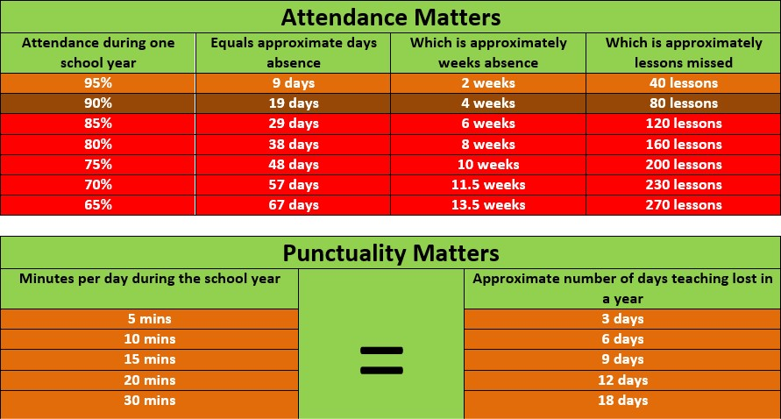

We expect parent(s) and/or carer(s) to:

* Ensure their child attends every day the school is open except when a statutory reason applies
* Notify the school as soon as possible when their child has to be unexpectedly absent (e.g. sickness)
* Only request leave of absence in exceptional circumstances and do so in advance
* Book any medical appointments around the school day where possible
* Provide up to date and accurate contact information.
* Provide the school with more than one emergency contact.
* Keep in regular contact with the school during a period of absence.
* Contact the school for support if school attendance/punctuality is a challenge.

We expect children and young people to:

* Attend lessons and any alternative provision as arranged by the school.
* Be punctual to lessons.
* Talk to an adult in school if they find attending school/being punctual a challenge.

### Children who do not attend every day

Where parents decide to have their child registered at school, they have an additional legal duty to ensure their child attends school regularly. This means their child must attend every day that the school is open, except in a small number of allowable circumstances such as being too ill to attend or being given permission for an absence in advance from the school.

The law entitles every child of compulsory school age to an efficient, full-time education suitable to their age, aptitude, and any special educational need they may have. It is the legal responsibility of every parent to make sure their child receives that education either by attendance at a school or by education otherwise than at school.

If a child of compulsory school age fails to attend regularly at a school at which they are registered, or at a place where alternative provision is provided for them, their parents may be guilty of an offence and can be prosecuted by the local authority. A child is of compulsory school age from the beginning of the term following their 5th birthday until the last Friday in June in the year in which they become 16, provided that their 16th birthday falls before the start of the next school year.

### The consequences of failing to secure a child’s regular attendance

* Parents who fail to comply with a school attendance order issued by the local authority to require a parent to get their child registered at a named school (under section 443 of the Education Act 1996). This may result in a fine of up to level 3 (£1,000).
* Parents who fail to secure their child’s regular attendance at a school, for which there are 2 separate offences: section 444(1) where a parent fails to secure the child’s regular attendance; and section 444(1A) where a parent knows that the child is failing to attend school regularly and fails to ensure the child does so. The section 444(1) offence may result in a fine of up to level 3 (£1,000) and the section 444(1A) offence my result in a fine of up to level 4 (£2,500), and/or a community order or imprisonment of up to 3 months.
* Parents who fail to secure the regular attendance of their child at a place where the local authority or governing body has arranged alternative provision (under sections 444 and 444ZA). This may result in a fine of up to level 3 (£1,000), or if the parent is found to have known the child was not attending regularly and failed to ensure that they did so, a fine of up to level 4 (£2,500), and/or a community order or imprisonment of up to 3 months.
* Parents who persistently fail to comply with directions under an Education Supervision Order (under Schedule 3 to the Children Act 1989) or breach a Parenting Order or directions under the order (under section 375 of the Sentencing Act 2020). These may result in a fine of up to level 3 (£1,000)

Both parents, all natural parents, whether they are married or not, all those who have parental responsibility for a child or young person, those who have day to day responsibility for the child (i.e. lives with and looks after the child) are equally liable for ensuring that their child attends school regularly and on time, regardless of who the child resides with or who is the main carer.

Therefore, they may both be contacted when deemed necessary in managing attendance and punctuality. Similarly, where it is necessary to enforce statutory action (such as issuing of Penalty Notices) both parents will be liable.

## **5. How absence and attendance is categorised**

The national attendance and absence codes enable schools to record and monitor attendance and absence in a consistent way and are used to collect statistics through the School Census system.

There are two different types of absences:

An **authorised absence** is where: -

1) a child is too ill to attend school (as per UK Health Security Agency guidance below) and

* + after a period of 5 days medical evidence has been provided.
  + for a child who has already been absent from **school for 6 days or more** and medical evidence is provided.
  + medical evidence is provided for absence immediately before or after a period of school holiday.
  + medical evidence is provided where there is a regular pattern to illness absence.

2) Evidence is provided for exceptional medical appointments.

3) The absence is unavoidable and exceptional.

4) A leave of absence for exceptional circumstances has been granted by the school.

An **unauthorised absence** is where: -

1. medical evidence is not provided for an illness absence of **school for 6 days or more.**
2. medical evidence is not provided for a child who has already been absent due to illness from **school for 6 days or more.**
3. medical evidence is not provided for illness absence immediately before or after a period of school holiday.
4. medical evidence is not provided where there is a regular pattern to illness absence.
5. the school considers that the absence was not unavoidable or exceptional.
6. a leave of absence request is declined but still taken (this includes holidays in term time).
7. Reasons for absence have been falsified.

## **6. Absence from school due to illness**

All pupils should attend school unless they are too ill to do so. Illness may be either a physical illness or a mental health/emotional wellness issue. The school will request reasonable medical evidence in cases where they need clarification to accurately record absence in the attendance register. Only where the school has genuine and reasonable doubt about the authenticity of the illness should medical evidence be requested to support the absence.

However, illnesses may not mean a child cannot attend school. Schools and parents are asked to refer to UK Health Security Agency guidance below.

Where a child requires medication throughout the school day to enable them to attend school parents/carers should liaise with the school who may make suitable arrangements in line with the school’s ‘Administration of Medication Policy’. If there are circumstances effecting a child’s health and ability to attend school parents/carers should again liaise with the school so that reasonable adaptations can be made (For example, in hay fever seasons it is not necessary to keep a child at home when school may be able to make adaptions).

Where a pupil has significant health or medical needs schools may develop a personalised ‘Health Care Plan’ which it will implement to ensure that the pupil continues to have excellent school attendance.

Schools encourage parents to notify them on the first and every day the child is unable to attend due to illness. Schools record absences as authorised where pupils cannot attend due to illness (both physical and mental health related).

Schools should authorise absences due to illness unless they have genuine cause for concern about the veracity of an illness. If the school has a genuine and reasonable doubt about the authenticity of illness, they can request that parents provide medical evidence to support illness. Schools can record the absence as unauthorised if not satisfied of the authenticity of the illness but should advise parents of their intention.

Medical evidence can take the form of prescriptions, appointment cards. The school does not expect parents to ask the GP for a fit note. Where a consultant is involved in supporting the child any correspondence from them could be provided. All pupils should return to school as soon as they are well enough.

### Pupils who are too ill to attend school

Pupils with long term illness or other health needs may need additional support to continue education, such as alternative provision arranged by the local authority. Local authorities are responsible for arranging suitable education for children of compulsory school age who, because of health reasons, would otherwise not receive suitable education. This applies whether or not the child is registered at a school and whatever type of school they attend. The education must be full-time or as close to full-time as the child’s health allows. DfE’s statutory guidance on ensuring a good education for children who cannot attend school because of health needs sets out that local authorities should provide education as soon as it is clear that the child will be away from school for 15 days or more, whether consecutive or cumulative. Local authorities should have a named officer responsible for the education of children with additional health needs.

## **7. Other absence from school**

There are very few circumstances where other absence from school will be authorised.

### Medical Appointments

Schools encourage parents to make appointments outside of school hours. Where this is not possible, they should get the school’s agreement in advance and the pupil should only be out of school for the minimum amount of time necessary for the appointment. Parents will be asked to provide evidence of medical appointments which fall inside the school day.

### Hospital Appointments

Schools will ask parents to provide evidence of hospital appointments which fall inside the school day.Parents should avoid taking the child out for the entire school day for an appointment when it is practical for them to attend for part of the day. If the school considers that the child could have attended for part of the day but is absent for the whole day a proportionate unauthorised absence will be recorded.

### Requests for Leave of Absence – exceptional circumstances

Requests for leave in exceptional circumstances should be made at **least 2 weeks in advance** of the event and in writing using the Leave of Absence Request Form provided by the school. Retrospective approval for absence cannot be granted. Parents do not have the right of appeal if a request for a leave of absence is declined, the head teacher’s decision is final.

Where requests for leave of absence are not authorised

* for pupils who have already been absent from school for **6 days or more**, regardless of the reasons for previous absence.
* for pupils **when the requested leave of absence will mean that they have absence amounting to 6 days or more.**
* during periods of public examinations or internal school assessments.
* for holidays during term time regardless of circumstances.

Where leave of absence is NOT authorised and parents decide to take pupils out of school despite the school’s decision, absence will be recorded as unauthorised and subject to a penalty notice (fine).

If the school grants a leave of absence request and subsequently obtains evidence that indicates an application was falsified, the school reserves the right to amend the child’s attendance records to record the absence as unauthorised and apply for the issuing of a fixed penalty notice.

Where a pupil fails to return to school after an agreed period of leave of absence, absence will be recorded as unauthorised, a penalty notice (fine) requested, and they may be reported to the Local Authority as ‘A Child Missing in Education’ and potentially lose their place at the school.

### Absences due to religious observance

A request for leave of absence wherever possible should be made 2 weeks prior to the date of the religious observance. As a general rule ‘a day exclusively set apart from religious observance’ is a day when the pupil’s parents would be expected by the religious body to which they belong to stay away from their employment in order to mark the occasion. The trust will not authorise further days in addition to the day exclusively set apart for religious observance.

### Absences for Elite Sporting Events and Pathways

Elite sport is sport at the highest level of competition, national and/or international. Where an elite sporting organisation requires a pupil to participate in a weekly scheduled training session or event a leave of absence form should be completed by the parent(s)/carers(s) and accompanied by an official supporting letter from the relevant sporting organisation. This letter should confirm the selection of the pupil in an elite performance squad or pathway and the necessity to regularly train during the school day in order to be an ongoing member of that squad/pathway. The request for this type of leave is considered by a member of the senior leadership team and will be reviewed on a termly basis.

Requests will not be considered from parent()/carer(s) without the required evidence as outlined above. The school is not able to authorise absence for extra training sessions when not requested/required by the organisation who have selected the pupil.

If the request is approved the school will contact the sporting organisation directly for additional information such as evidence of their safeguarding procedure and confirmation that the necessary vetting checks have been undertaken.

### Absences for participating in a regulated performance

A school can grant leaves of absence for pupils to undertake employment (paid or unpaid) during school hours. The school can only do so where the local authority has granted a licence for the pupil to take part in a performance which is regulated by section 37(2) of the Children and Young Persons Act 1963. Where a pupil does not need a licence for such a performance because there is a Body of Persons Approval (BOPA) covering the pupil and this has been issued by the local authority in whose area the performance will take place. Whilst the school is able to grant leaves of absence on these occasions attendance will be monitored and where this becomes of concern, they may contact to local authority who granted the licence.

### Children Missing in Education

Where a pupil has been absent from school for a period of **20** consecutive school days without authorisation or has not returned within **10** days after an authorised (requested) absence a pupil can be removed from the admissions register when the school and LA have failed to establish the whereabouts of the pupil.

## **8. Day to Day Procedures**

### Attendance Registers

Schools take an attendance register at the start of each morning session and once during the afternoon session. The school uses BROMCOM information management system to ensure the accurate recording of attendance information, the ease of data analysis and sharing.

Attendance registers are legal documents and are preserved for a period of 6 years.

The school uses the national attendance codes to ensure attendance and absence are recorded in a consistent way.

Attendance registers are not amended or altered unless the reason for absence is established after the register has closed. Any amendments to the register include the original entry, the amended entry, the reason for amendment, the date of amendment and the name and role of the person who made the amendment.

### Morning Registration

The school gates open to welcome pupils at 08:30am. Reception and Year 1 classroom doors will open at 8:30am and Year 2 at 8:45am. The classroom doors will close at 8:45am. Pupils arriving after the classroom doors have closed must *report to the school office, be signed in by parent, reason for lateness given and recorded*. Pupils who are late, after the gates have closed, are marked as late before the register closes (L code).

Morning registration is open from 8:45am and closes 9:15am. Pupils arriving after registration closes (after 9:15am), are marked as late after register closes (U code). This is an unauthorised absence and negatively impacts a pupil’s attendance percentage.

### Afternoon Registration

Afternoon registration is open from 13:00 and closes at 3:15*.* Pupils arriving after registration closes (after 13:30), are marked as late after register closes (U code). This is an unauthorised absence and negatively impacts a pupils attendance percentage.

### Lesson Registration

In secondary schools attendance and punctuality registers are also taken **for**

individual lessons.

### Leaving the Premises During the School Day

In accordance with statutory guidance, medical and dental appointments should be made outside of school hours, but if this is not possible then please send confirmation of the appointment to the school office.

Children are not permitted to leave school during the day unless accompanied by a parent/carer, and they will be signed out at the school office on leaving, and signed in again upon their return.

If a child leaves the school site without permission, their parents/carers will be contacted. Should the school be unable to make contact with the family it may be appropriate, in certain circumstances, to contact the Police and register the child as a missing person.

This applies to all pupils, including those of non-statutory school age.

### Notifying the school of a child’s absence

Parents/carers must notify school on the first and every day the child is unable to attend school by 9:15am.

Parents must give detailed reasons for absence. For example, ‘child has a throat infection/been sick etc’ rather than just ‘unwell/poorly’.

Name of person absence should be reported to: Liz Roberts / Tim Bonny-Meekings – Office Manager / Clerical Assistant.

Contact Details: [fps-absence@fps.jtmat.co.uk](mailto:fps-absence@fps.jtmat.co.uk) / [office@fps.jtmat.co.uk](mailto:office@fps.jtmat.co.uk) – 01543 761030

Where a child (including those of non-statutory school age) is absent from school and parents/carers have not contacted the school to inform them of the reason for absence the school will record an unauthorised absence and follow safeguarding procedures to ascertain the reason for absence and whereabouts of the pupil. This may involve the school making contact with parents and other named contacts on record. If by the third day of absence no contact has been made the school will carry out a home visit and report the absence as a safeguarding concern or to the police.

Where there are pre-existing concerns about the safety or well- being of a pupil the school may carry out a home visit on the first day of absence. Where there are serious concerns about the safety and well-being of a pupil whose reason for absence is not known the school may contact the police, local authority, or children social care.

## **9. The relationship between safeguarding and absence**

In order to carry out Safeguarding responsibilities, when a pupil is absent from school for more than 5 days a member of school staff will be required to carry out a safe and well check on the child.

Home visits are important in helping the school to make contact with new or hard to reach families. They are particularly useful as they enable parents, carers or guardians to have contact with school, but in their own environment.

### The safeguarding duty of schools

* Pupils are refusing to come to school
* When there are attendance issues/concerns
* When pupils are being educated at home
* When all other means of contact with the family has failed
* To try and establish that a child is safe if they are absent from school and attempts to contact parents, carers or guardians have not elicited a response and we have any welfare or safeguarding concerns for the pupil.
* To work with parent(s)/carer(s) or guardians to support a child with an attendance issue.
* To collect from or drop off a child where there are concerns for a child’s welfare if they travelled by other means.
* To drop off or collect work for a child when they are completing schoolwork from home e.g. following a suspension, exclusion, or medical issue.
* To visit a child who has been off school for a period of time, for example due to medical issues, so that they do not feel isolated from school.
* To investigate situations where there are suspicions that someone may be on holiday contrary to earlier indications.
* Where there are safeguarding concerns about a pupil – on the first day of absence where no reason for absence has been ascertained
* Where there are safeguarding concerns about a pupil – on the third day of absence where no reason for absence has been ascertained
* For pupils who are absent from school for 3 days where no reason for absence has been ascertained, this can be completed earlier if there are concerns raised.

Where a child is absent from school for a prolonged period, school staff must ensure they see the child at least weekly. Ideally, this is to be completed face to face, however where distance may be a concern this could be conducted remotely, however the child must be seen, not just parent(s)/carer(s). This does not apply to students who have requested a leave of absence, either authorised or unauthorised unless there are specific safeguarding concerns. Where a child is hospitalised, it is appropriate for a member of staff to liaise with medical professionals to establish the wellbeing and safety of the child.

## **10. Communication**

### Parent Communication

Good attendance starts with close and productive relationships with parents and pupils. In working in partnership with parents, schools can discuss the link between attendance and attainment and wider wellbeing, and challenge parents’ views where they have misconceptions about what ‘good’ attendance looks like.

In order to ensure the school has effective procedures for managing attendance and absence the school and trust will follow a ‘Graduated Response’. Building positive relationships with parents(s)/carer(s) is important so that when a pupil is absent from school Below is a diagram of the type of contact a parent can expect from the school when their child is absent, and no reason has been provided. The school is responsible for adhering to safeguarding protocols and where they have concerns, they are expected to take advice from either Staffordshire Education Safeguarding Advice Service/Derbyshire etc.

Parent communication flow chart

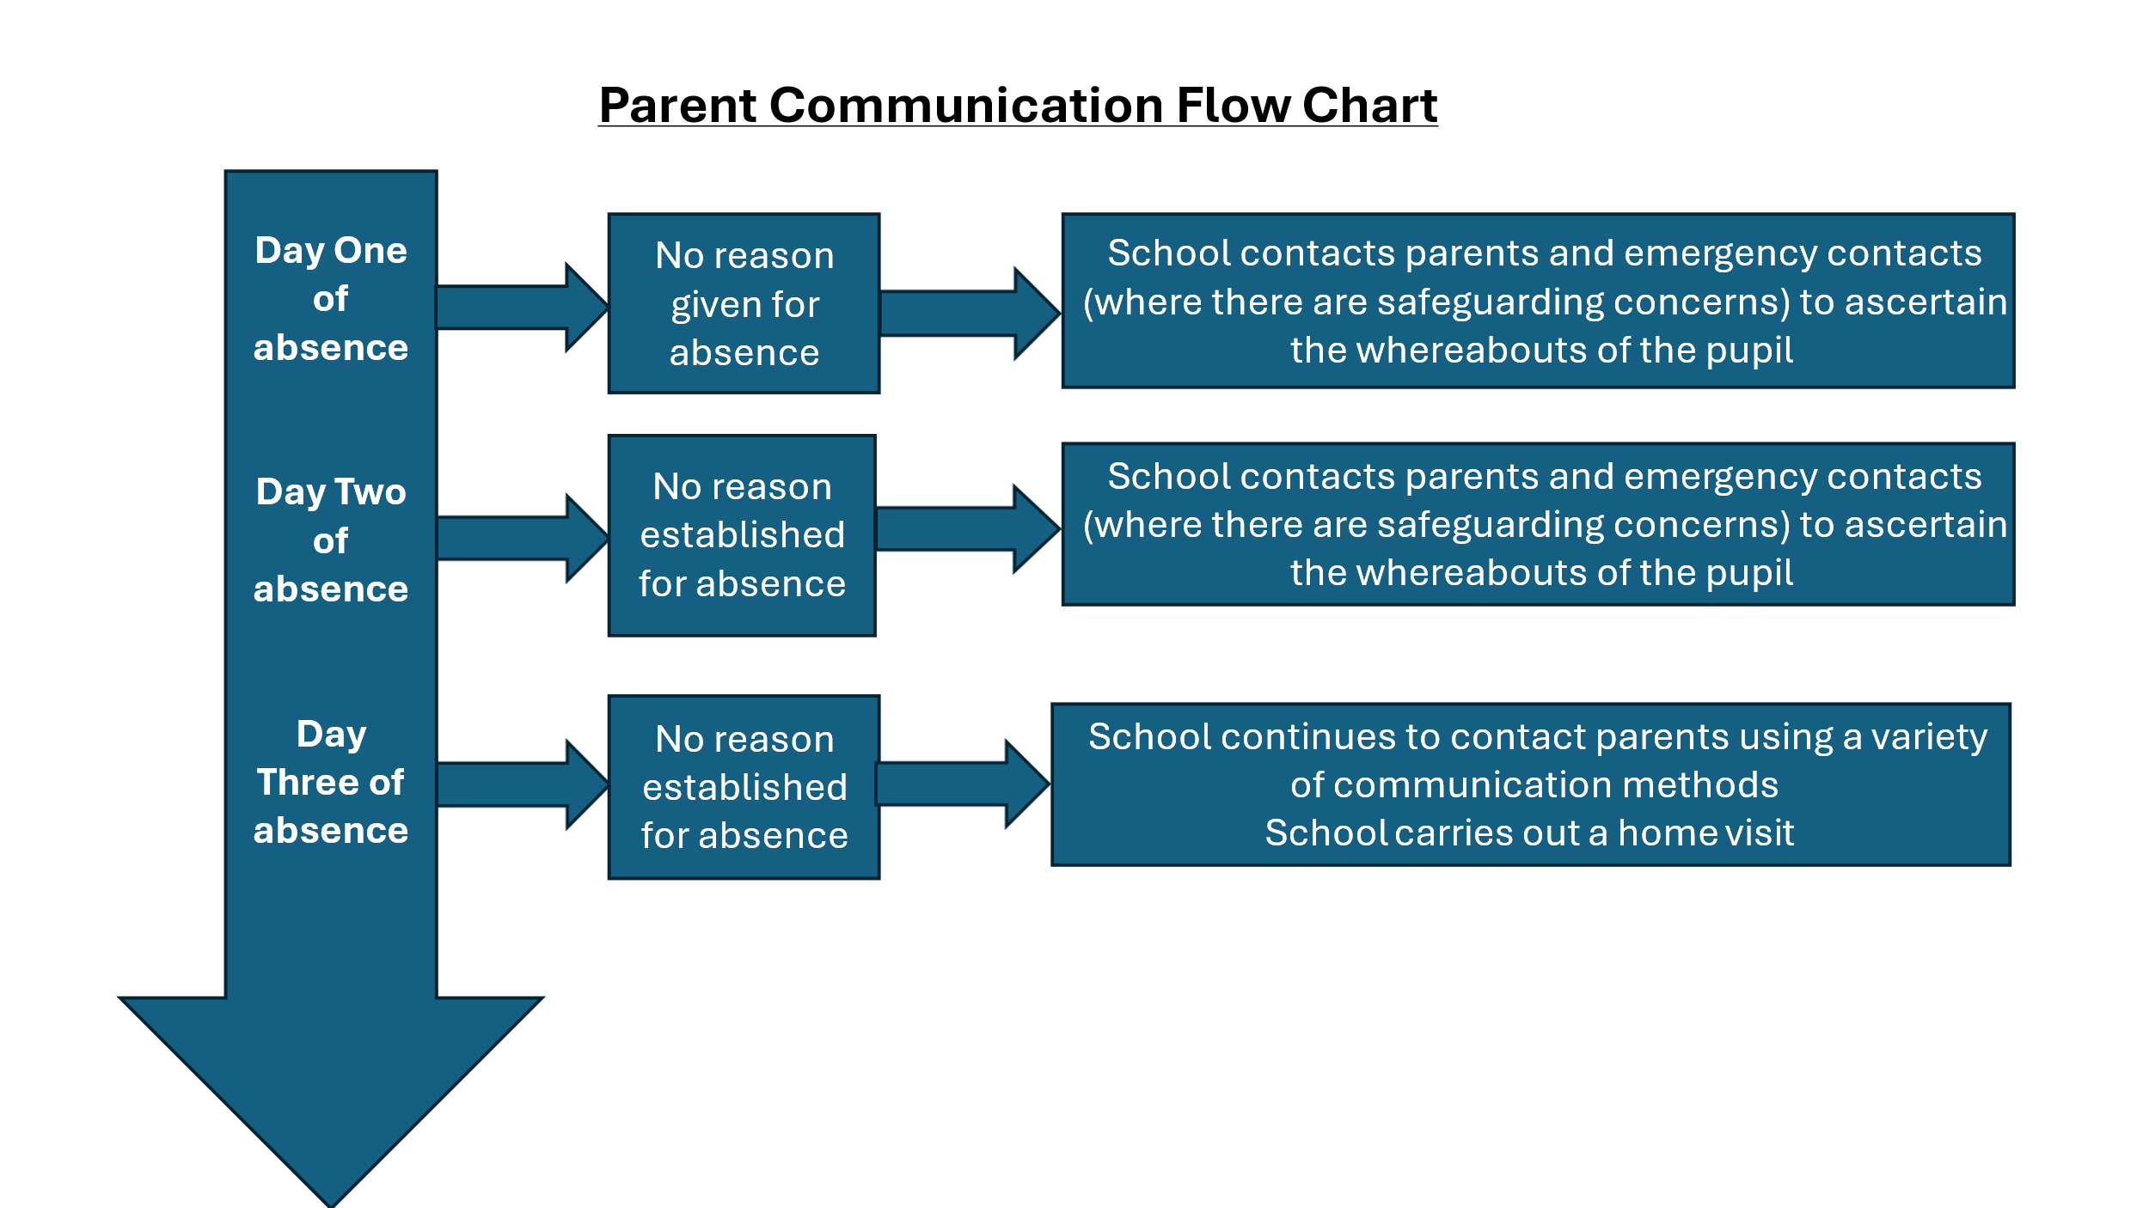

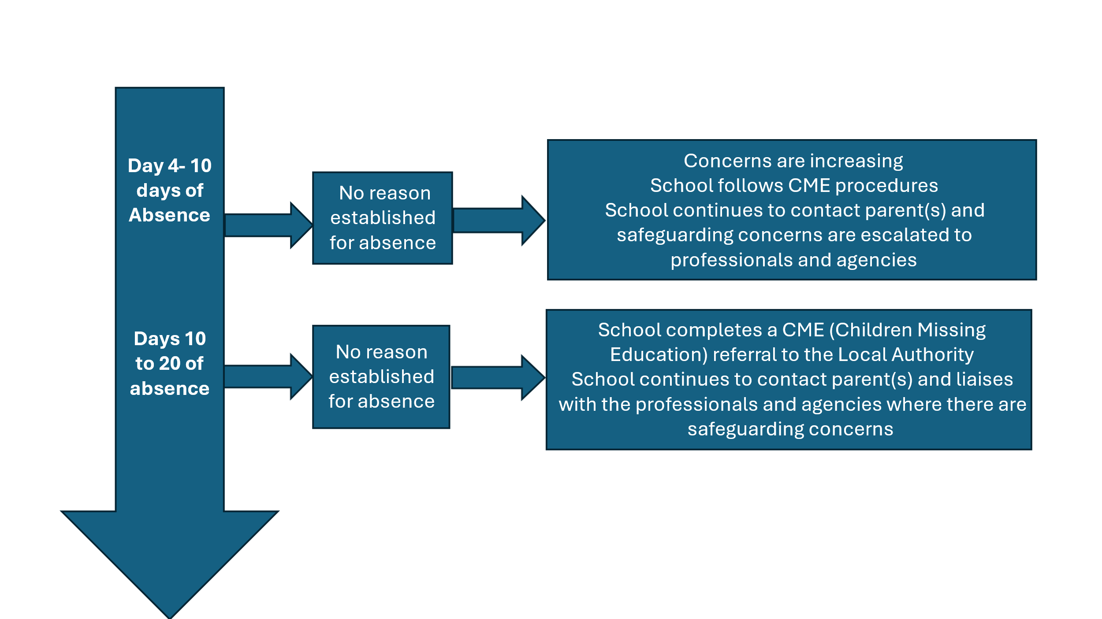

* Please note this can be flexible dependant on the reason for absence

## **11. The John Taylor MAT Graduated Response from Early Years to Post-16**

Our school aims to work to cultivate strong, respectful relationships with parents and families so that we can build trust and positive relationships. Open and honest communication is maintained with pupils and their families about the expectations of school life, attendance, and performance so that they understand what to expect and what is expected of them. The school liaises with other agencies working with pupils and their families to support attendance, e.g. local policing teams, children social care and early help team from the local authority.

In our school we use the Graduated Response to manage attendance. The flow chart below shows the actions that (name of school) takes as the number of days that a pupil is absent increases.

### School intervention process

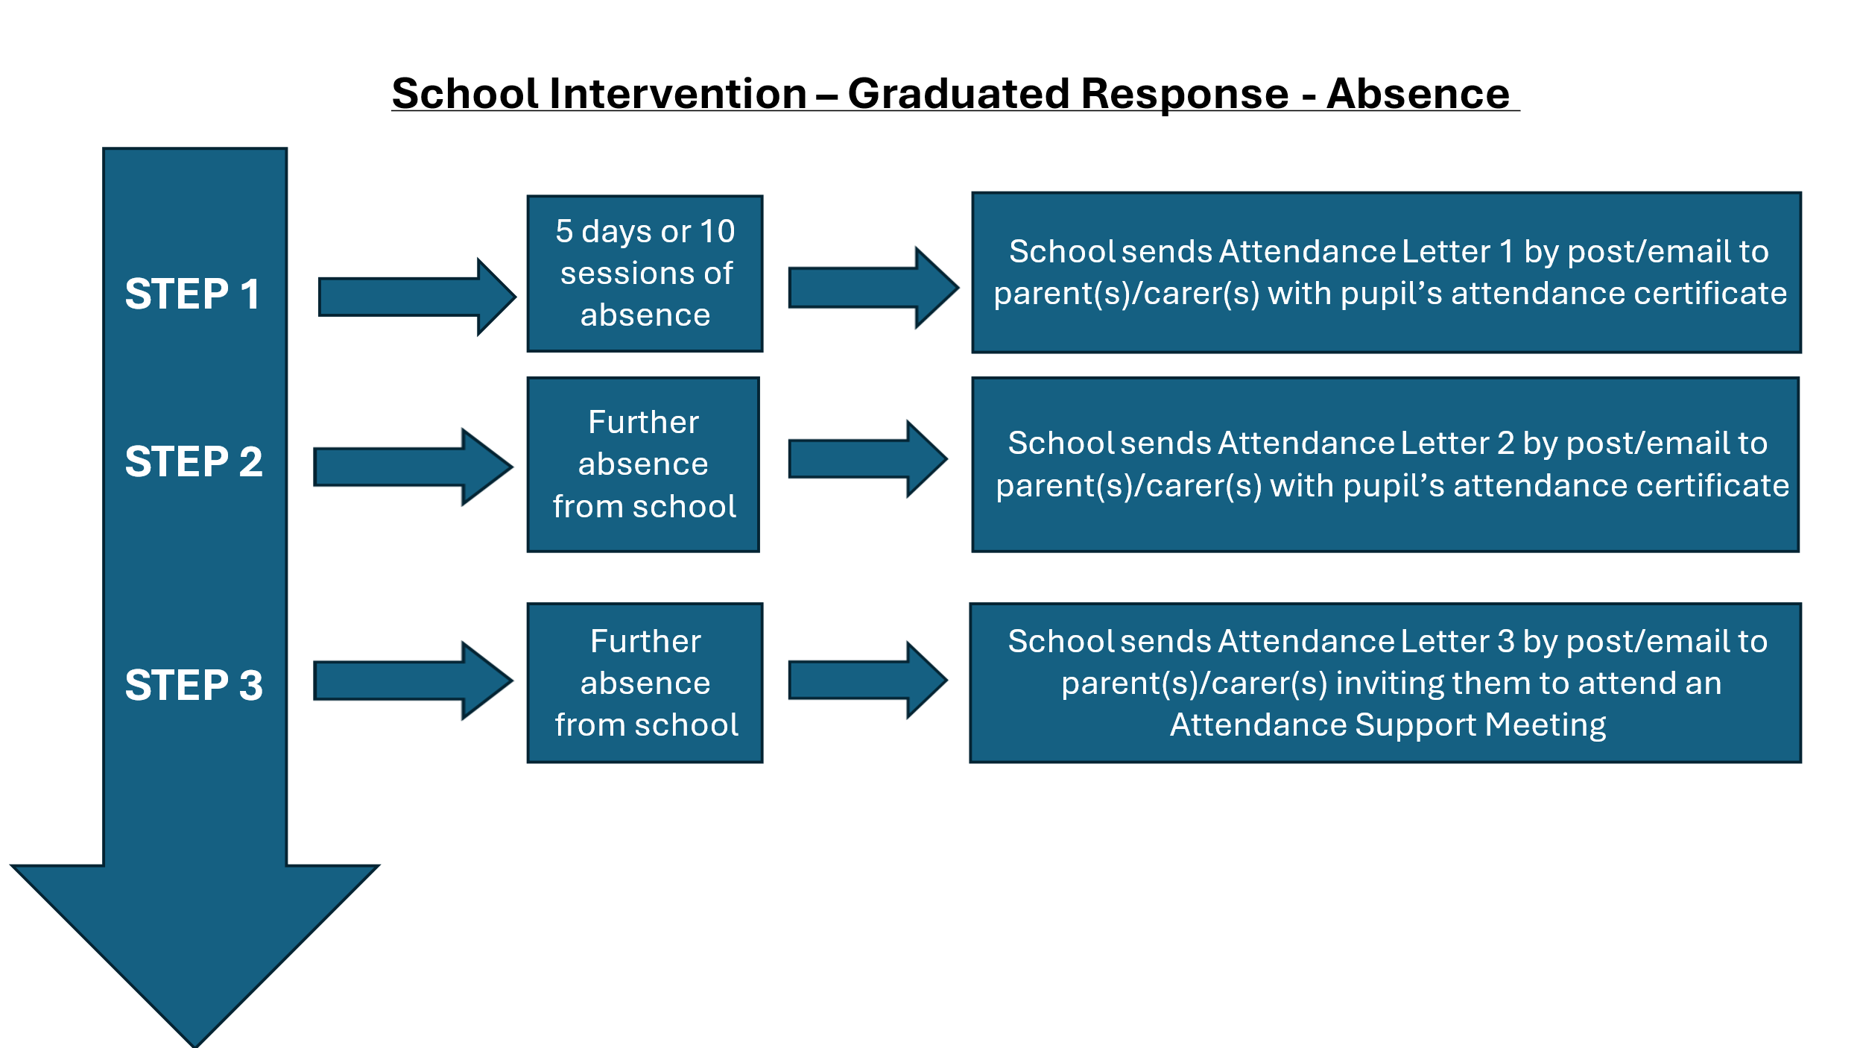

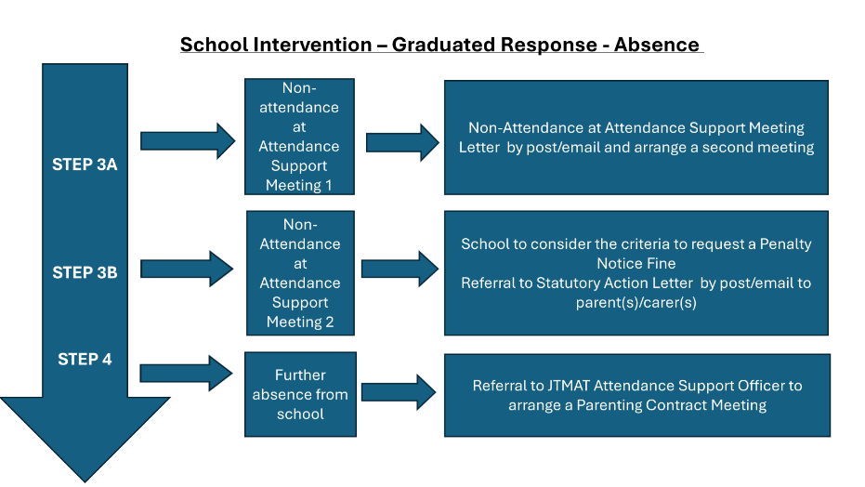

### First Day Calling Process

In addition, our school operates a First Day Calling process for when a pupil is absent, and no reason has been provided by the parent(s) and/or carer(s) for absence. The school ensures there are two sets of emergency contact details for each pupil wherever possible to ensure the school has additional options for getting in touch with adults responsible for a pupil where the pupil is absent without notification or authorisation.

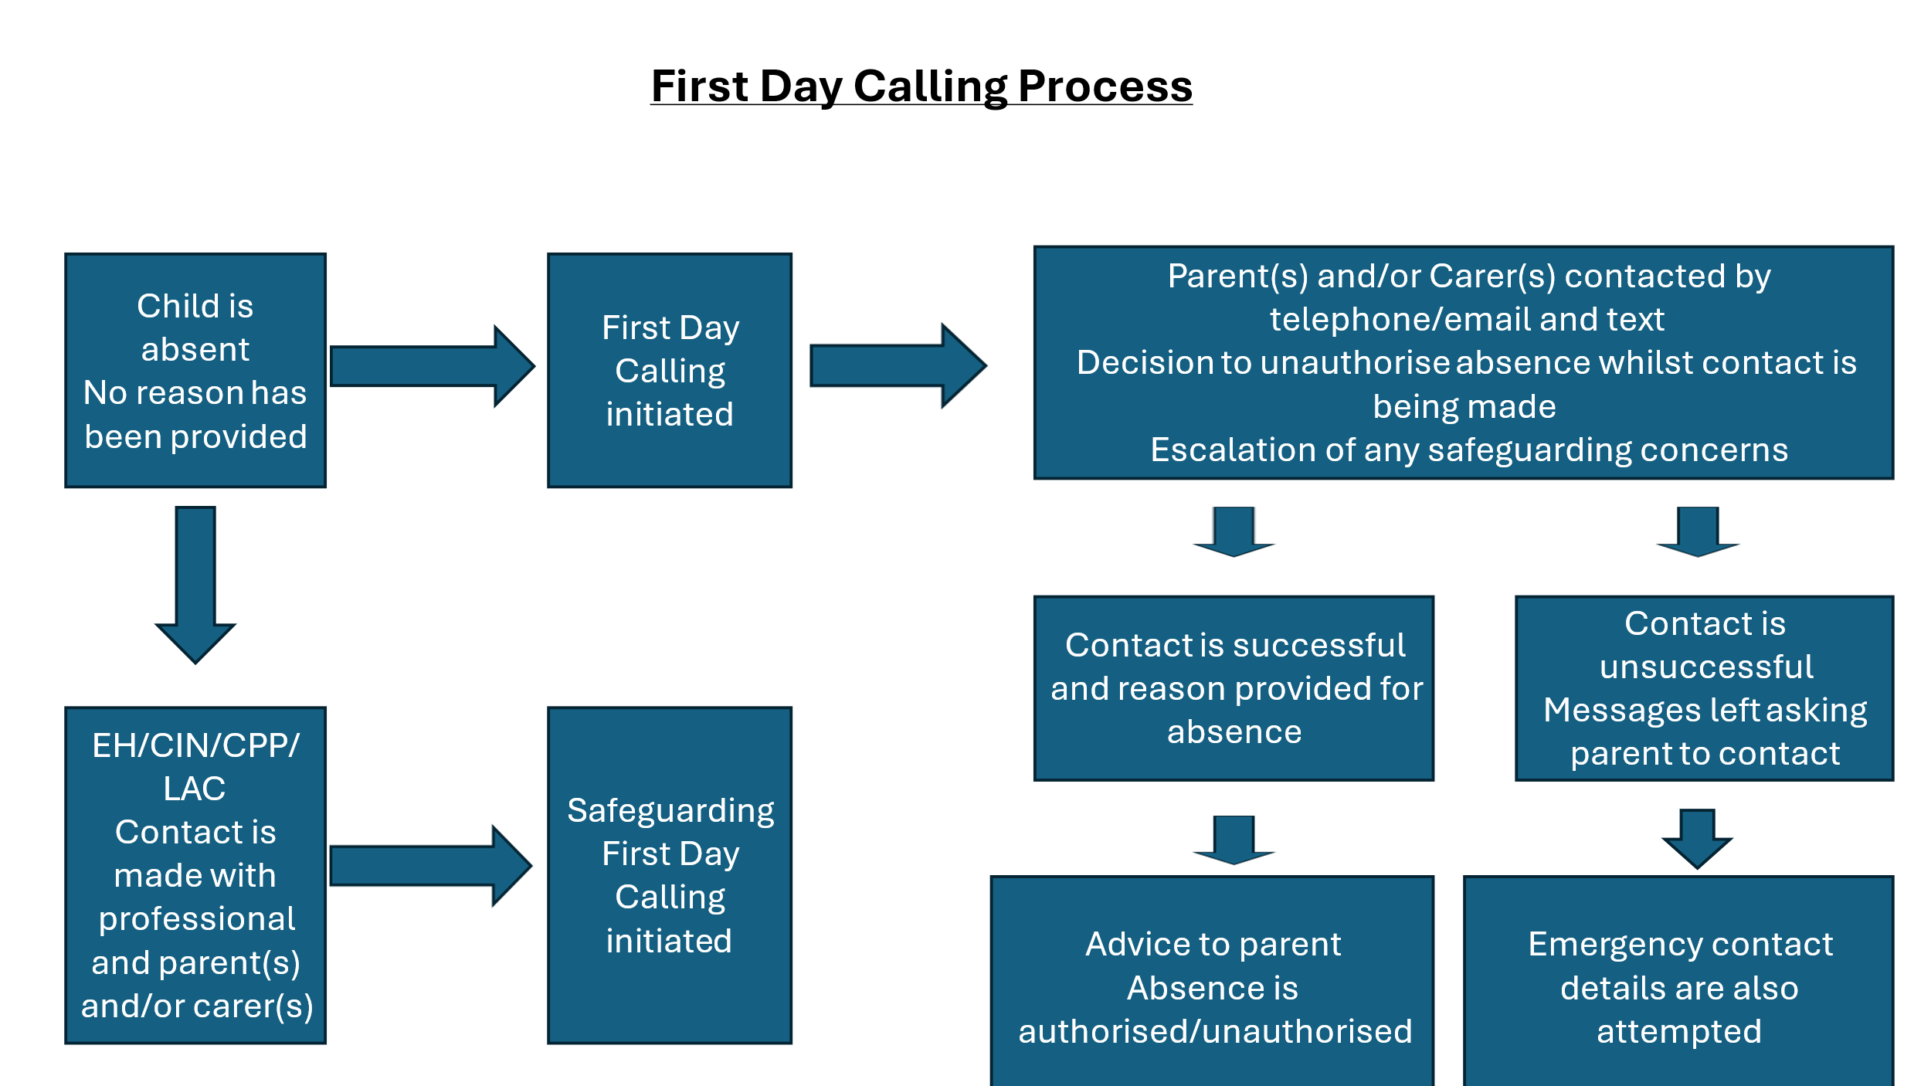

### When reasons for absence have not been provided

When reasons have not been provided by the parent(s) and/or carer(s) for unexplained absence from school it is important for the school to contact quickly to speak with you about the reasons. It may be that the school can offer some additional help or support in some way to address barriers to attendance. For example:

* Considers if an Early Help Assessment is appropriate
* To offer support through an Attendance Support Plan
* Send a letter asking for reasons for the absence(s)
* Invitation to attend a meeting in school
* Suggest referring to a voluntary agency or community group

In our school, we have additional support for pupils who have barriers to attending school regularly. For example, support from the Mental Health Lead and SENDCo if appropriate, ELSA support, Early Help Assessments.

All pupils and parents/carers are urged to contact the school if they feel that they are facing challenges to ensure their child attends regularly. In the first instance you should contact Mrs Chrissie Allen on – 01543 761030.

### Reporting an absence from school

For reporting a child’s absence parent(s) and/or carer(s) should contact:

Liz Roberts or Tim Bonny-Meekings on:

[fps-absence@fps.jtmat.co.uk](mailto:fps-absence@fps.jtmat.co.uk) / [office@fps.jtmat.co.uk](mailto:office@fps.jtmat.co.uk) – 01543 761030

We want to ensure that parent(s)/carer(s) are aware of their legal duty to ensure that their child attends school regularly and to facilitate their child’s legal right to a full-time education – parents will be made aware that this means their child must attend school every day that it is open, save for in certain circumstances, e.g., sickness or absences that have been authorised by the headteacher in advance. The school regularly inform parents about their child’s levels of attendance, absence, and punctuality, and will ensure that parents are aware of the benefits that regular attendance at school can have for their child educationally, socially and developmentally.

If a pattern of absence becomes problematic, Mrs Allen works collaboratively with the pupil and their parents to improve attendance by addressing the specific barriers that prevent the pupil from being able to attend school regularly. The school always takes into consideration the sensitivity of some of the reasons for pupil absence and will approach families to offer support rather than immediately reach for punitive approaches.

Where these barriers are related to the pupil’s experience in school, e.g., bullying, the attendance officer works with the headteacher and any relevant school staff, e.g. the DSL and SENDCO, to address this. Where the barriers are outside of the school’s control, e.g., they are related to issues within the pupil’s family, the DSL’s liaises with any relevant external agencies or authorities, e.g., local policing teams, children’s services and early help teams and will encourage parents to access support that they may need.

### Supporting pupils with SEND and/or health conditions

We recognise that pupils with SEND and/or health conditions, including mental health issues, may face greater barriers to attendance than their peers, and will incorporate robust procedures to support pupils who find attending school difficult.

In line with the SEND Policy and Supporting Pupils with Medical Conditions Policy, the school ensures that reasonable adjustments are made for pupils with disabilities to reduce barriers to attendance, in line with any EHCP plans or IHCPs that have been implemented. The school secures additional support from external partners to help bolster attendance where appropriate.

The contact details for our SENDCo are:

Miss J Pearson – 01543 761030 – [office@fps.jtmat.co.uk](mailto:office@fps.jtmat.co.uk)

### Supporting pupils with mental health and safeguarding concerns

Where the school has concerns that a pupil’s non-attendance may be related to mental health issues, parents are contacted to discuss the issue and whether there are any contributory factors to their child’s lack of attendance. Where staff have a mental health concern about a pupil that is also a safeguarding concern, they inform the Designated Safeguarding Lead, and the Child Protection and Safeguarding Policy is followed. All pupils are supported with their mental health in accordance with the school’s Social, Emotional and Mental Health (SEMH) Policy.

The contact details for our Designated Safeguarding Lead are:

Mrs C Allen – 01543 761030 – [office@fps.jtmat.co.uk](mailto:office@fps.jtmat.co.uk)

If a pupil is unable to attend school for long periods of time due to their health, the school will:

* Inform the Local Authority if a pupil is likely to be away from the school for more than **15** school days.
* Provide the Local Authority with information about the pupil’s needs, capabilities, and programme of work.
* Help the pupil reintegrate at school when they return.
* Make sure the pupil is kept informed about school events and clubs.
* Encourage the pupil to stay in contact with other pupils during their absence.

The school implements an Attendance Support Plan to help any pupils with SEND and/or health issues cope with the stress and anxiety that attending school may cause them. Such plans will be regularly monitored and reviewed until the pupil is attending school as normal and there have been signs of significant improvement.

### Post-16 Attendance Process

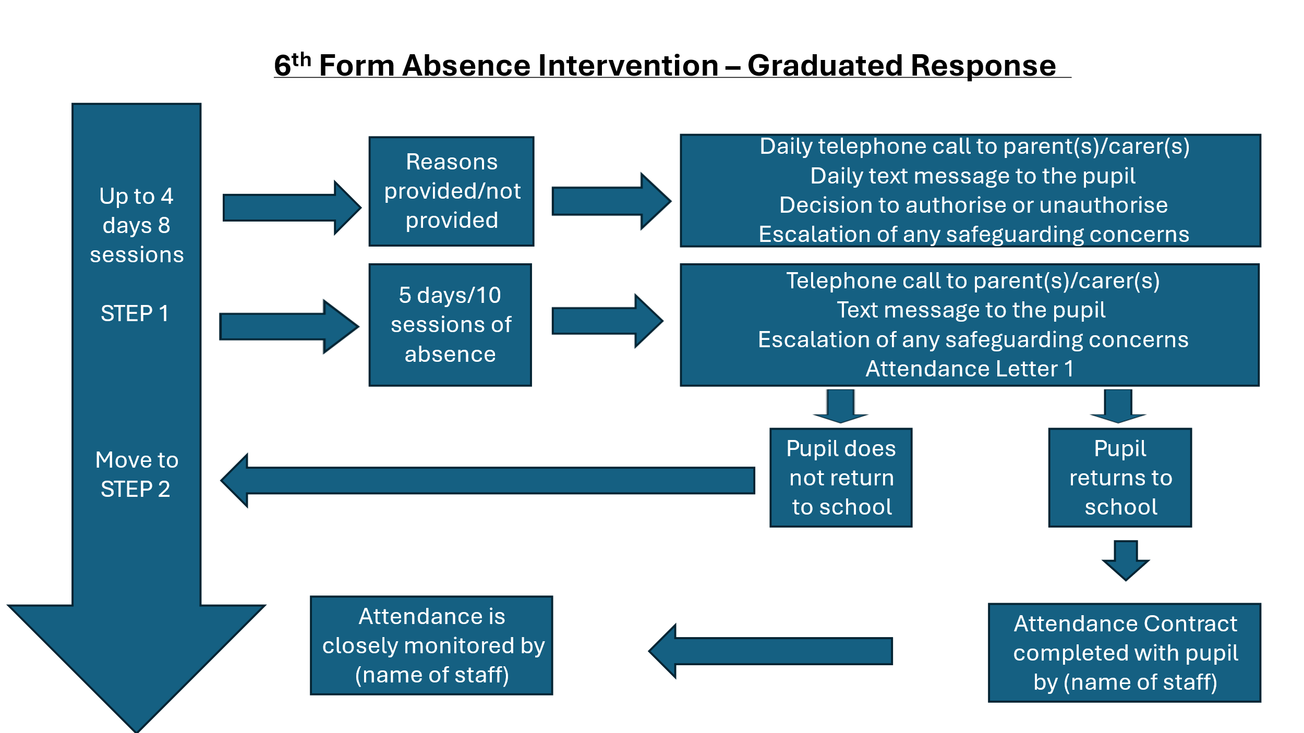

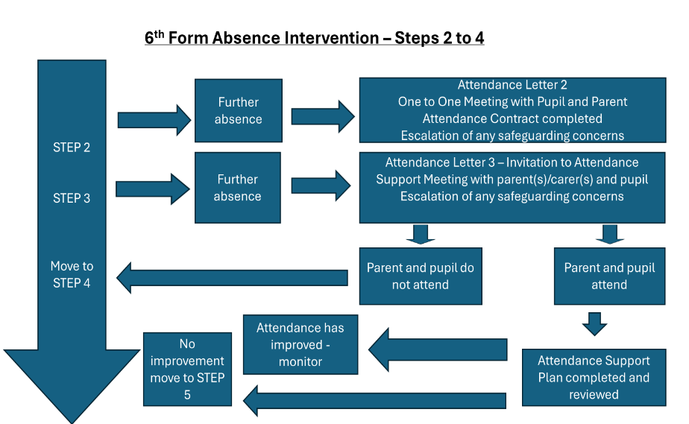

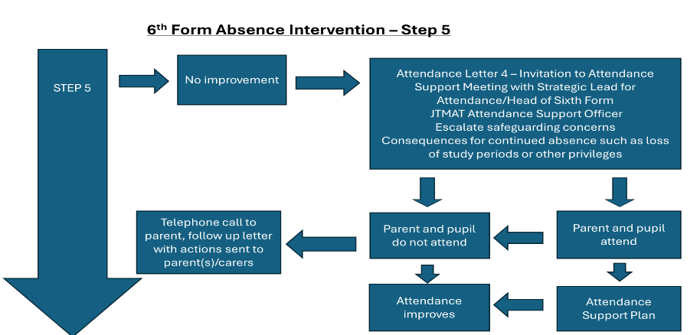

### Early Years Attendance Process

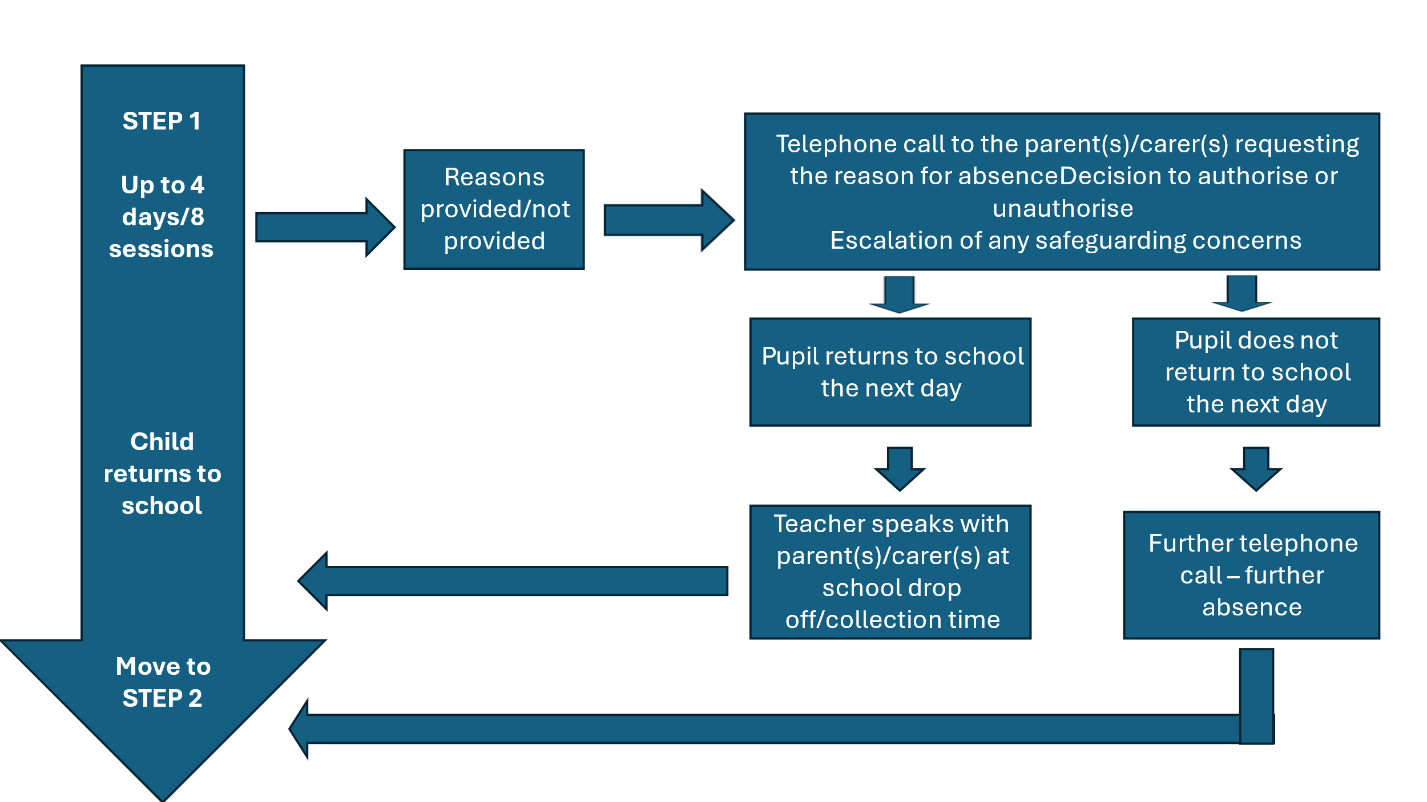

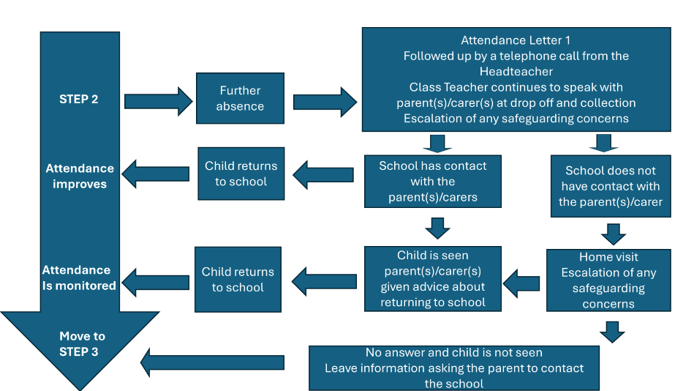

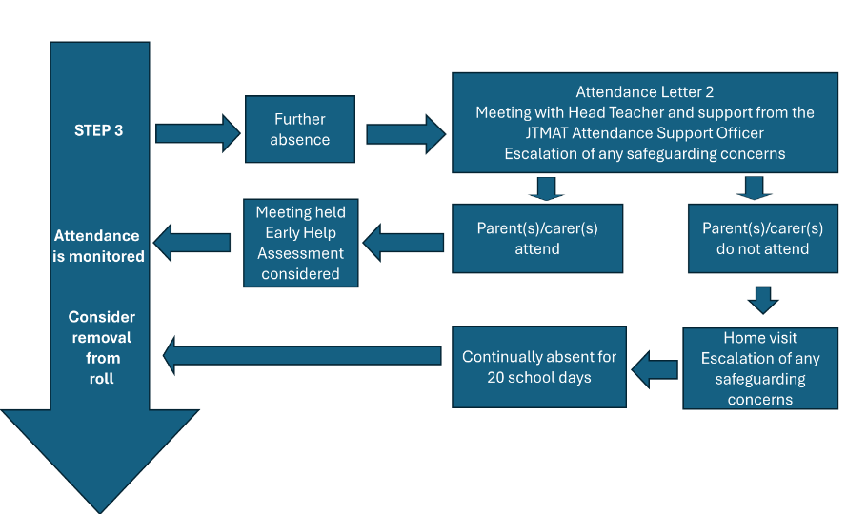

## **12. Persistent and Severe Absence Strategy**

Where absence escalates and pupils miss 10% or more of school (equivalent to 10 day or more across a full school year), referred to as persistent absence, we work with the local authority to put in additional targeted support in place to remove any barriers to attendance and reengage persistently absent pupils. We consider some of the reasons for absence and understand the importance of school as a place of safety and support for children who might be facing difficulties, rather than reaching immediately for punitive approaches.

In addition, we particularly focus on pupils who are absent from school more than they are present, those missing 50% or more of school, referred to as severely absence. Some pupils may find it more difficult to be in school or face bigger barriers to their regular attendance and as such are likely to need more intensive support across a range of partners.

Severely and persistently absent pupils are an area of focus in our regular data monitoring approach, to identify pupils and cohorts who need targeted attendance support as quickly as possible.

Our strategy looks like this:

There are various groups of pupils who may be vulnerable to high absence and persistent or severe absence, such as:

* Children in need
* LAC (Looked after Children)
* Young carers
* Pupils who are eligible for FSM (Free School Meals)
* Pupils with EAL (English as an Additional Language)
* Pupils with SEND (Special Education Need and Disability)
* Pupils who have faced bullying and/or discrimination

We ensure that we provide support to pupils at risk of persistent absence, in conjunction with all relevant external authorities where necessary. The school uses a number of methods to help support pupils to attend school. These may include:

* Offering catch-up support to build confidence and bridge gaps in learning.
* Meeting with the pupil and their parent to discuss patterns of absence, barriers to attendance, and any other problems they may be having.
* Establishing plans to remove barriers and provide additional support.
* Leading weekly check-ins to review progress and assess the impact of support.
* Making regular contact with the pupil’s parent to discuss progress.
* Assessing whether an EHCP plan or IHCP may be appropriate.
* Considering whether an Early Help Assessment may be appropriate
* Considering what support for re-engagement might be needed, including with regard to additional vulnerability.

Where a pupil at risk of persistent or severe absence is also at increased risk of harm, the school will work in conjunction with all relevant authorities, e.g., children’s services to support the pupil in line with the school’s duty of care. The school will also bear in mind that the continuation of absence following intervention may, in itself, constitute neglect, and will escalate any concerns in this regard in line with the Child Protection and Safeguarding Policy.

## **13. Attendance legal intervention**

As absence is so often a symptom of wider issues a family is facing, the school and the trust work together with other local partners to understand the barriers to attendance and to provide support. The school allows sufficient time for attendance interventions and engagement strategies to improve pupils’ attendance; however, where engagement strategies to improve attendance do not have the desired effect or parents fail to engage in the support being offered, the school will consider referring to the (name of local authority) to consider statutory action.

This may involve requesting the LA to issue a penalty notice (fine); referring to the LA for prosecution as a final resort and referring to children’s social care where there are safeguarding concerns and concerns about educational neglect.

### Educational neglect

Access to education and school attendance is not usually considered as neglect by itself. Attendance to school is a legal requirement and prosecution can be sought in cases where parents fail to deliver on their responsibilities. Due to the legal power of prosecution as set out below, attendance is often considered as a separate education issue to the safeguarding definition of neglect.

Section 7 Education Act 1996 places a duty on parents to ensure that their child of compulsory school age receives a suitable education, either by regular attendance at school or otherwise. Where parents fail to provide this, they can be prosecuted under Section 4441 or 4441A of the Act.

Children have a legal right to an education and so failing to send the child to school regularly is an example of educational neglect. Article 28 of the United Nations Convention Rights of the Child says that “*children and young people have the right to education no matter who they are: regardless of race, gender, or disability; if they are in detention, or if they’re a refugee”*.

The Equality Act 2010 puts a responsibility on public authorities to have due regard to the need to eliminate discrimination and promote equality of opportunity. This applies to the process of identification of need and risk faced by the individual child and the process of assessment. No child or group of children must be treated less favourably than others in being able to access effective service which meet their needs. This includes access to education through regular attendance at school.

Non-attendance to school is a symptom that something is wrong. If we consider the definition of neglect as set out in the Working together to Safeguard Children (2018) it is easy to see how education and school attendance fit within the description.

#### Education threshold for “persistent failure” to meet the child’s basic needs

* Failure of inadequately maintaining access to education
* Failure to ensure regular attendance at school or arrival on time
* Failure to provide an education or apply for a school place to enable access to education
* Failure to consent to assessment to explore unmet or undiagnosed need that may require higher threshold support, intervention, or specialist provision
* Failure to attend assessments or appointments related to health or education
* Failure to engage with the school or local authority services and support offered
* Failure to engage with the specific action contained within the Education Health Care Plan or other formalised plan offered by the school, local authority or imposed by the magistrate or family court

### Education threshold for ‘serious impairment of development’ of the child:

* 84% of Key Stage 2 pupils who had 100% attendance achieved the expected standard, compared to 40% of pupils who were persistently absent across the key stage (data from 2019).
* Pupils who did not achieve the expected standard in reading, writing and maths in 2019 had an overall absence rate of 4.7% over the key stage, compared with 3.5% among pupils who achieved the expected standard and 2.7% among those who achieved the higher standard.
* Among pupils with no missed sessions over KS4, 83.7% achieved grades 9 to 4 in English and maths compared to 35.6% of pupils who were persistently absent.
* Pupils who did not achieve grade 9 to 4 in English and maths GCSEs in 2019 had an overall absence rate of 8.8% over the key stage, compared with 5.2% among pupils who achieved a grade 4 and 3.7% among pupils who achieved grade 9 to 5 in both English and maths.

## 

## **14. The National framework for penalty notices**

### What is a penalty notice?

Penalty notices are issued to parents as an alternative to prosecution where they have failed to ensure that their child of compulsory school age regularly attends the school where they are registered or, in certain cases, at a place where alternative provision is provided. Penalty notices can be used by all schools (with the exception of independent schools) where the pupil’s absence has been recorded with one or more of the unauthorised codes and that absence(s) constitutes an offence. A penalty notice can be issued to each parent liable for the offence or offences. They should usually only be issued to the parent or parents who have allowed the absence (regardless of which parent has applied for a leave of absence).

Penalty notices are intended to prevent the need for court action and should only be used where it is deemed likely to change parental behaviour and support to secure regular attendance has been provided and has not worked or been engaged with or would not have been appropriate in the circumstances of the offence (e.g. an unauthorised holiday in term time). Local authorities can consider earlier if there is a clear attempt to avoid the 5-day threshold.

### How penalty notices are issued

Penalty notices must be issued in line with the Education (Penalty Notices) (England) Regulations 2007, as amended and can only be issued by a headteacher or someone authorised by them (a deputy or assistant head), a local authority officer or the police. They must also be issued in line with Local Codes of Conduct which are drawn up and maintained by each local authority.

Where a penalty notice is issued by someone other than a local authority officer, the person issuing the penalty notice is expected to check with the local authority before doing so and must also send them copies of any penalty notices issued.

A penalty notice may also be issued where parents allow their child to be present in a public place during school hours without reasonable justification during the first 5 days of a fixed period or permanent exclusion. The school must have notified the parents of the days the pupil must not be present in a public place. This type of penalty notice is not included in the National Framework and therefore not subject to the same considerations about support being provided or count towards the limit as part of the escalation process in the case of repeat offences for non-attendance.

### What is the national threshold to issue a penalty notice?

All schools in the Trust will follow the National Framework for Penalty Notices. **The threshold is 10 sessions of unauthorised absence in a rolling period of 10 school weeks.** A school week means any week in which there is at least one school session.

This can be met with any combination of unauthorised absence (e.g. 4 sessions of holiday taken in term time plus 6 sessions of arriving late after the register closes all within 10 school weeks). These sessions can be consecutive (e.g. 10 sessions of holiday in one week) or not (e.g. 6 sessions of unauthorised absence taken in 1 week and 1 per week for the next 4 weeks). The period of 10 school weeks can also span different terms or school years (e.g. 2 sessions of unauthorised absence in the Summer Term and a further 8 within the Autumn Term).

### Notices to improve

A Notice to Improve is a final opportunity for a parent to engage in support and improve attendance before a penalty notice is issued. If the national threshold has been met and support is appropriate but offers of support have not been engaged with by the parent or have not worked, a Notice to Improve should usually be sent to give parents a final chance to engage in support.

## **15. Monitoring and Analysing Attendance and Punctuality**

The Strategic Lead for Attendance in each school will monitor and analyse attendance data weekly to ensure that intervention and support is delivered quickly to address attendance issues.

The school will collect and report attendance data to the Trust Strategic Attendance Manager, Governors, School’s Senior Leadership Team, lead professionals for vulnerable groups (e.g. PP, SENDCO, EAL, heads of year etc) at least half-termly. The Trust Strategic Attendance Manager will in turn collect and report attendance data to the CEO and Trust Board at least termly.

Data collected and analysed will include data for attendance, persistent absence and severe absence:

* The school cohort as a whole
* Individual year groups
* Pupils from vulnerable groups – Pupil Premium, Free School Meals, Education Health Care Plan, Special Education Need and disability English as Additional Language, Social Worker, Looked after Child
* Any other groups deemed to be at risk of poor attendance

The Strategic Lead for Attendance and the Trust Strategic Attendance Manager will conduct thorough analysis of the data half-termly, termly and annually to identify patterns and trends; individual or groups of pupils needing support/intervention. Analysis is then used to develop and implement action plans/interventions to improve attendance.

Analysis will also include identification of:

* Types of absence (codes)
* Patterns in days of absence
* Lessons which have poor attendance
* Barriers to attendance

Attendance data will be bench marked against national data and comparative data for the previous academic year. The Trust Strategic Attendance Manager for Attendance visits each school within the trust at least termly to review attendance data, analysis, trends, impact of intervention and progress towards targets.

Schools are legally required to share information from their attendance registers with the local authority and in the future with the DFE.

## **16. Summary**

JTMAT and its schools are committed to promoting excellent school attendance for all its pupils (both of statutory and non-statutory school age). We are also committed to working in a collaborative and supportive manner with pupils, families, external agencies and other schools and trusts to support excellent attendance.

## **17. Useful Legislation and Guidance**

[Parental rights and responsibilities: Who has parental responsibility - GOV.UK (www.gov.uk)](https://www.gov.uk/parental-rights-responsibilities/who-has-parental-responsibility)

### Legislation

[Education Act 1996 (legislation.gov.uk)](https://www.legislation.gov.uk/ukpga/1996/56/section/444)

[Children Act 1989 (legislation.gov.uk)](https://www.legislation.gov.uk/ukpga/1989/41/contents)

[Crime and Disorder Act 1998 (legislation.gov.uk)](https://www.legislation.gov.uk/ukpga/1998/37/contents)

[Anti-social Behaviour Act 2003 (legislation.gov.uk)](https://www.legislation.gov.uk/ukpga/2003/38/contents)

[The School Attendance (Pupil Registration) (England) Regulations 2024 (legislation.gov.uk)](https://www.legislation.gov.uk/uksi/2024/208/contents/made)

[The Education (Penalty Notices) (England) Regulations 2007 (legislation.gov.uk)](https://www.legislation.gov.uk/uksi/2007/1867/contents/made)

[Equality Act 2010 (legislation.gov.uk)](https://www.legislation.gov.uk/ukpga/2010/15/contents)

### Guidance

[Children missing education - GOV.UK (www.gov.uk)](https://www.gov.uk/government/publications/children-missing-education)

[Keeping children safe in education - GOV.UK (www.gov.uk)](https://www.gov.uk/government/publications/keeping-children-safe-in-education--2)

[Working together to safeguard children - GOV.UK (www.gov.uk)](https://www.gov.uk/government/publications/working-together-to-safeguard-children--2)

[SEND code of practice: 0 to 25 years - GOV.UK (www.gov.uk)](https://www.gov.uk/government/publications/send-code-of-practice-0-to-25)

[Alternative provision - GOV.UK (www.gov.uk)](https://www.gov.uk/government/publications/alternative-provision)

[Supporting pupils with medical conditions at school - GOV.UK (www.gov.uk)](https://www.gov.uk/government/publications/supporting-pupils-at-school-with-medical-conditions--3)

[Education for children with health needs who cannot attend school - GOV.UK (www.gov.uk)](https://www.gov.uk/government/publications/education-for-children-with-health-needs-who-cannot-attend-school)

[Promoting and supporting mental health and wellbeing in schools and colleges - GOV.UK (www.gov.uk)](https://www.gov.uk/guidance/mental-health-and-wellbeing-support-in-schools-and-colleges)