
Pupil Premium Strategy Statement 
This statement details our school’s use of pupil premium funding to help improve the attainment of our disadvantaged pupils for the 2025 to 2026 academic year.

It outlines our pupil premium strategy, how we intend to spend the funding in this academic year and the effect that the previous pupil premium strategy plan (2022-2025) had within our school.

School overview
Detail | Data
School name | Fradley Park Primary and Nursery School
Number of pupils in school | 135  (106 excluding Nursery)
Proportion (%) of pupil premium eligible pupils | 5.7 %
Academic year/years that our current pupil premium strategy plan covers (3-year plans are recommended) | 2025/26 – 2027/28
Date this statement was published | December 2025
Date on which it will be reviewed | June 2026
Statement authorised by | Chrissie Allen  Hannah Sinnett
Pupil Premium Lead | Chrissie Allen (HT)
Governor / Trustee Lead | Hannah Sinnett (COG)

Funding overview
Detail | Amount
Pupil Premium funding allocation this academic year | £10,205.00
Early Years Pupil Premium funding allocation this academic year | £0
Recovery Premium funding allocation this academic year | £0
Pupil premium funding carried forward from previous years (enter £0 if not applicable) | £0
Total budget for this academic year  If your school is an academy in a trust that pools this funding, state the amount available to your school this academic year | £10,205.00

Part A: Pupil premium strategy plan

Statement of intent
All members of staff and the local governing body accept responsibility for disadvantaged pupils and are committed to meeting their pastoral, social and academic needs within a caring and nurturing environment and in line with the Government’s Operation Mission are determined “to drive high and rising standards and ensure every child, no matter their background, can achieve and thrive”. Irrespective of a disadvantaged pupils’ background or the challenges they face we are determined to ensure that they make good progress and achieve high attainment across all subject areas. This Pupil Premium (PP) strategy statement will ensure support for all vulnerable pupils at Fradley Park Primary and Nursery School.
Realising the potential in every child, their whole self - for today and for their future selves - and using every moment they are in our care, to make this happen, quickly, is the belief that underpins our work at Fradley Park and this PP strategy statement. We aspire for each child to develop a love for learning and acquire skills and abilities commensurate with fulfilling their potential and as an adult finding employment.
“It is vital that schools get this right. Every child who leaves school without the right qualifications faces a far more difficult path to fulfilling their potential and finding employment. We owe it to all our young people to ensure that they are given every chance to succeed.” Sir Michael Wilshaw in the Ofsted 2012, Evaluation of the Pupil Premium Spending.
Overcoming barriers to learning is at the heart of our Pupil Premium Grant use. We understand that needs and costs will differ depending on the barriers to learning being addressed. As such, we do not automatically allocate personal budgets per student in receipt of the Pupil Premium Grant. Instead, we identify the barrier to be addressed, and the interventions required, whether in small groups, large groups, the whole school or as individuals, and allocate a budget accordingly.
Our priorities are as follows:
- Closing the attainment gap between disadvantaged pupils and their peers
- Ensuring all pupils receive high-quality teaching each lesson
- Providing targeted academic support for pupils who are not making the expected progress
- Addressing non-academic barriers to attainment such as attendance, behaviour and well – being
- Providing time and resources for staff to access relevant CPD (Continuing Professional Development) that will support the above priorities
- Ensuring that the Pupil Premium Grant reaches the pupils who need it most

Challenges
This details the key challenges to achievement that we have identified among our disadvantaged pupils.
Challenge number | Detail of challenge
1 | Attendance  Ensuring that we reduce absence rates for our disadvantaged pupils’ is an on-going priority. Through a whole school approach, we will focus on ensuring that the attendance gap for our disadvantaged pupils and non-disadvantaged pupils is narrowed and that the impact poor attendance has on attainment and poor mental health/wellbeing is reduced.  Using research and findings from the DfE and EEF in guidance such as.  Working together to improve school attendance (applies from 19 August 2024)  Attendance toolkit for schools.pdf  Supporting school attendance | EEF  our response to improving the attendance and punctuality of individual children and families will be a responsive one tailored to meet the individual needs of pupils and their families.
2 | Emotional Literacy and Mental Health support  On-going reviews of pupil progress in Pupil Progress Meetings and work with families, indicates that disadvantaged pupils require additional intervention and support to develop emotional literacy skills, confidence, and good self-esteem.  Our case load for ELSA and Playmobile Therapy and our work with CAMHS (Child and Adolescent Mental Health Services) continues to be high indicating a demand for additional interventions and strategies that can be used within the classroom to support the mental health and well-being of our disadvantaged pupils.
3 | Ensuring that the progress and attainment of disadvantaged pupils is in line with their peers.  Reading, Writing and Phonics  Assessments, observations, and discussions with staff and parents about the attainment and progress of disadvantaged pupils at the end of 2024-2025 indicates some aspects of literacy require further targeted support.  Oracy and Communication and Language  Building on previous strategy statements by ensuring that a sharp focus on developing oracy is evident in every lesson, in every classroom, in every provision to provide opportunity for all pupils, but particularly disadvantaged pupils to receive high quality modelling and multiple opportunities across the curriculum to develop their oracy skills.

Intended outcomes
This explains the outcomes we are aiming for by the end of our current strategy plan, and how we will measure whether they have been achieved.

Intended outcome | Success criteria
Achieve and sustain improved attendance and consistent punctuality for all pupils, particularly our disadvantaged pupils. | - Improving attendance is a key school development priority.  - Children are punctual and display high levels of attendance in line with national expectations.  - Pupils and their families are supported with regular attendance through the application of school and JTMAT (John Taylor Multi Academy Trust) attendance policies and procedures.  - Bespoke 1-1 support is provided to disadvantaged pupils and their families to improve attendance at school  - Families whose children are classed as disadvantaged are supported effectively to address barriers which may prevent them from attending e.g. school trips, school events, uniform, resources, additional learning resources/tools.  - Attendance incentives are in place which support and recognise regular or improved attendance through celebration events, activities, and rewards.
Support our disadvantaged pupils to cope with life's daily challenges and develop age-appropriate emotional literacy skills and positive mental health strategies | - Pupil-led peer support and mental health strategies are implemented across school.  - Reflective spaces and regulation/behaviour strategies are evident in every classroom.  - Through assess, plan, do, review approach, and monitoring of interventions, pupils show they develop strategies that support their emotional literacy and positive mental health.  - Through PPM and termly assessments, pupils show progress in meeting PSED/PSHE objectives and demonstrate improved SEMH.  - Key Person’s and Teachers alongside Parents/Carers observe and report positively on progress made in this area for disadvantaged pupils.  - Participation in enrichment activities, particularly amongst disadvantaged pupils, is supporting the development of happy, healthy pupils with increased confidence.
Improvement in the abilities of disadvantaged pupils to read and write in line with the taught knowledge and skills of non-disadvantaged peers. | - Disadvantaged pupils access reading support as appropriate to their need through small group interventions and 1-1 keep up support delivered by trained teachers/teaching assistants.  - Parents are provided with the knowledge and additional support materials and support reading/writing regularly at home.  - Additional 1-1 reading/phonics support is provided by volunteers and additional adults in school.  - Teacher knowledge and skills in the teaching of handwriting and spelling is supported through high-quality professional development and resources. Teachers understand what disadvantaged pupils need to learn to be successful in English and how to teach and assess this
Improved language and oracy skills across the whole school particularly for disadvantaged pupils | - Disadvantaged pupils make accelerated progress in language development and oracy using Voice 21 strategies and professional development for teaching teams.  - Pupil’s development of oracy skills ensure that they have greater access to the curriculum.  - Pupils demonstrate improved confidence when communicating and wider use of vocabulary and improved sentence structures.

Activity in this academic year
This details how we intend to spend our pupil premium this academic year to address the challenges listed above.

Teaching (for example, CPD, recruitment and retention)
Budgeted cost: £5840.50
Activity | Evidence that supports this approach | Challenge number(s) addressed
Training for the whole school team in understanding the attainment gaps for disadvantaged and vulnerable children in Staffordshire through the Virtual School.  Training for individual staff members on understanding children and young people’s behaviours through the application of an attachment and trauma lens.  Training Calendar 25-26 December 25 Update | Improving Social and Emotional Learning in Primary Schools | EEF | 2
Train an additional staff member to lead the emotional literacy support work in school and qualify as an ELSA (Emotional Literacy Support Assistant).  Reaccreditation of current ELSA to support whole school knowledge and expertise and application to school-wide relationships, routines and environments.  Resources for Emotional Literacy Support Assistants - ELSA Support | Improving Social and Emotional Learning in Primary Schools | EEF  Research – ELSA Network | 2
On-going professional support for Teaching Assistants delivering EPATT (Educational Psychology Assessment Through Teaching Tool).  This is an online assessment and monitoring tool that is part of the Staffordshire Educational Psychology (EP) Literacy Approach).  It is a comprehensive, highly effective reading approach that includes an online assessment and monitoring tool (EPATT) and a daily intervention. | Using 1-1 and small group tutoring, ideally involving structured interventions supports children struggling with aspects of literacy.  Improving Literacy in Key Stage 1 | EEF  EPATT Progress Data: Evidence from schools implementing the approach shows that children are making an average of 10 months reading age progress in a single term. | 3
Embed the use of a toolkit of strategies that teach self-regulation techniques to pupils throughout the school day and into the daily class routine.  Calmaclass Toolkit (School Access) – CalmaClass | Self-regulation strategies | EEF  Improving Social and Emotional Learning in Primary Schools | EEF  Evidence suggests that children from disadvantaged backgrounds have on average, weaker SEL skills at all ages than their more affluent peers. These skills are likely to influence a range of outcomes for pupils: lower SEL skills are linked with poorer mental health and lower academic attainment.  SEL interventions in education are shown to improve SEL skills and are therefore likely to support disadvantaged pupils to understand and engage in healthy relationships with peers and emotional self-regulation, both of which may subsequently increase academic attainment. | 2
Upskill pupils in supporting their own positive mental health and emotional wellbeing and that of their peers through a structured teaching programme in KS2 that gives pupils the tools to face life’s challenges confidently.  www.onegoal.co.uk | Self-regulation strategies | EEF  Improving Social and Emotional Learning in Primary Schools | EEF | 2
Roll out a whole school strategic approach to the teaching of spelling to support the progress and attainment of disadvantaged pupils.  Spelling Shed - Spelling game for school and home | Improving Literacy in Key Stage 1 | EEF  Improving Literacy in Key Stage 2 | EEF  Telling the story: the English education subject report - GOV.UK | 3
Through CPD, upskill all staff’s knowledge and skills in supporting attendance and creative a culture where everyone is responsible for attendance.  An Inclusive Approach to Improving Attendance - Inclusive Attendance  Attendance Champions to be trained and in place acting as a support for staff, parents and pupils especially those disadvantaged families.  Certificate in the Role of the Attendance Champion | Supporting school attendance | EEF  Build a holistic understanding of pupils and families, and… | EEF  Attendance toolkit for schools.pdf  Working together to improve school attendance (applies from 19 August 2024) | 1
Bespoke training to meet individual need of teaching teams to support the teaching of spelling  Spelling Shed - Spelling game for school and home  https://theteachhub.co.uk/ | Improving Literacy in Key Stage 1 | EEF  Improving Literacy in Key Stage 2 | EEF  Telling the story: the English education subject report - GOV.UK | 3
Through further professional development, continue to develop talk and communication as an essential skill that underpins attainment in all subjects. (Talk Circles are a set of ready-to-use oracy teacher training materials which can be used to suppose the development of high-quality oracy teaching practice throughout your school.  Talk Circles) | Telling the story: the English education subject report - GOV.UK  Voice 21: Improving Oracy - second pilot | EEF | 3
Through CPD and follow up planning meetings with senior leaders, enhance staff’s understanding of ‘barriers to learning’ for their pupils. Whole school staff to understand the attainment gaps for disadvantaged and vulnerable children in Staffordshire (RADY - “Raising the Attainment of Disadvantaged Youngsters”).  CPD to include:  - UPLIFT targets  - introduce EQUITY in teaching and learning  - use RADY as a golden thread through policies and improvement plans.  Virtual School Training Calendar - Staffordshire Virtual School  Completion of ‘Barrier to Learning’ overview for each class. | Why uniting the whole school community around disadvantage… | EEF  Raising the Attainment of Disadvantaged Youngsters - RADY - Staffordshire Virtual School | 1, 2, 3

Targeted academic support (for example, tutoring, one-to-one support structured interventions)
Budgeted cost: £2,340
Activity | Evidence that supports this approach | Challenge number(s) addressed
Structured Intervention -Playmobile Therapy | Improving Social and Emotional Learning in Primary Schools | EEF (educationendowmentfoundation.org.uk) | 1
- targeted support to  close identified gaps in key knowledge and skills | One to one tuition | EEF  Improving Literacy in Key Stage 1 | EEF | 2
Structured Intervention -ELSA | Improving Social and Emotional Learning in Primary Schools | EEF (educationendowmentfoundation.org.uk) | 1

Wider strategies (for example, related to attendance, behaviour, wellbeing)
Budgeted cost: £1,524.50 + £500 Contingency
Activity | Evidence that supports this approach | Challenge number(s) addressed
Attendance and punctuality of disadvantaged pupils is tracked and monitored regularly by SLT/Attendance Team and reported to the LGB.  Whole community attendance charter agreed and in place.  Attendance Team have robust systems in place for improving attendance and punctuality with all groups of pupils and these are reviewed regularly.  Wrap around provision is used to support regular attendance and reduce persistent absence and a supported place in this provision will be offered if appropriate. | Supporting school attendance | EEF  Build a holistic understanding of pupils and families, and… | EEF  Attendance toolkit for schools.pdf  Working together to improve school attendance (applies from 19 August 2024)  EEF Attendance Intervention research  Pupils being in school improves learning, resilience, aspirations, and confidence.  ‘One of the key characteristics across all the approaches within the report is monitoring and identification of pupils that need attendance support and the reasons for low attendance.’  ‘Many approaches to improving attendance to not have a specified “intervention” but instead aim to be responsive to the reasons for low attendance by an individual pupil. These approaches are often multi-component and may involve one to one support for the pupil that has low attendance.’ | 1, 2, 3
Extra-Curricular Clubs - disadvantaged children to have priority places offered and funded. | There are wider benefits from regular physical activity in terms of physical development, health, and wellbeing as well as other potential benefits have been reported such as improved attendance.  Physical activity | EEF (educationendowmentfoundation.org.uk) | 1, 2, 3
Contingency fund for access to educational visits and experiences, Including purchasing of appropriate clothing. | Based on our experiences and those of similar schools to ours, we have identified a need to set a small amount of funding aside to respond quickly to needs that have not yet been identified. | 1, 2, 3

Total budgeted cost: £10,205.00

Part B: Review of outcomes

Pupil Premium strategy outcomes
This details the impact that our pupil premium activity had on pupils in the previous pupil premium strategy plan:

Communication and Language Development
We have embedded speech and language support programmes (Stoke Speaks Our/NELI) within our EYFS over the last three years and use these competently to identify (screen) and support pupils’ communication and language skills in the Early Years. Training and on-going confidence in the delivery of these interventions is prioritised by Teaching Teams and SLT and support provided when appropriate.

Progress of children accessing language interventions continues to be monitored by the SENDCO alongside the teaching teams using tracking and summative assessment data. More complex, speech and language needs in pupils are swiftly identified and teaching teams work closely with Speech and Language therapists to implement any programs of support.

Summative assessments and teacher judgements/observations indicate significantly improved oral language amongst disadvantaged pupils because of additional interventions and strategies implemented through our Pupil Premium Strategy.

At the end of the academic year 2023-2024, 96.4 % (+3.4% on previous academic year) of the Reception cohort were in line with expectations in Communication and Language. 100% of PP children met the expected level of attainment in Communication and Language. At the end of the academic year 2024-25, 100% of the Reception cohort were in line with expectations in Communication and Language. 100% of PP children met the expected level of attainment in Communication and Language

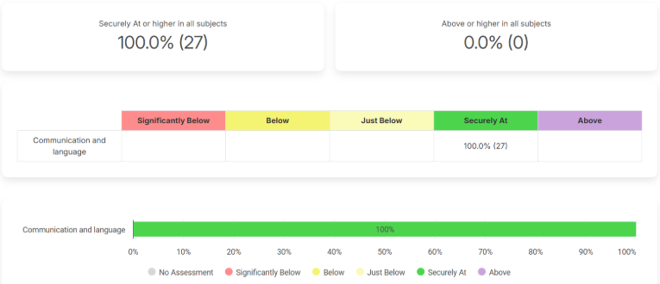

Support for all pupils, including our disadvantaged pupils, to develop strong communication and language skills has been positively impacted by the 3-year pupil premium strategy plan and allocation of resources.

Attendance
Overall, attendance at the end of 2024-2025 was broadly in line with attendance at the end of 2022-2023 through additional interventions and monitoring. We ensured that our most vulnerable children were attending school regularly and reduced persistent absence over the course of the 3-year strategy plan. We have maintained attendance levels above national averages despite pupil numbers growing significantly each year.

Historical Attendance Picture:
 | 2021-22 | 2022-23 | 2023-24 | 2024-2025
Overall Attendance | NA | 95.5% | 96.3% | 95.3%
Overall, PA | NA | 10.7% | 5.1% | 5.6%

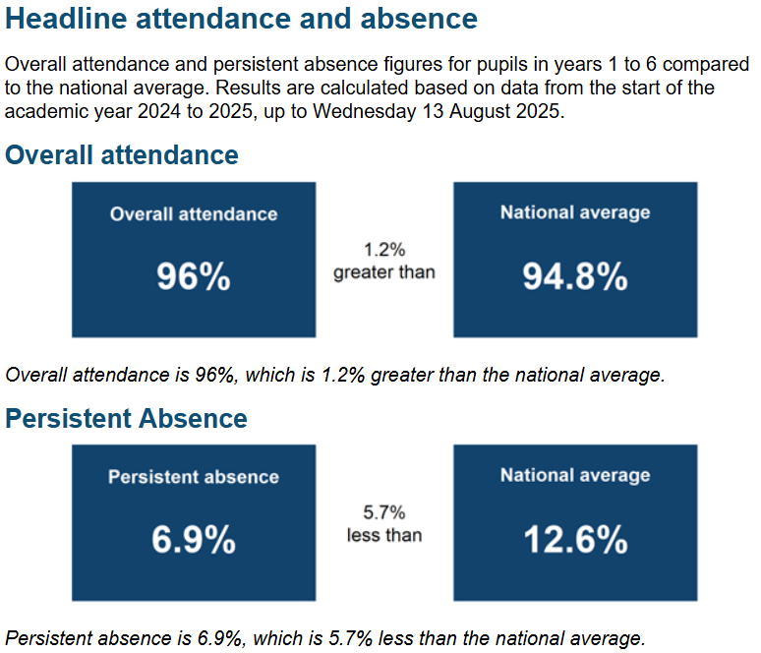

A gap of 1.8% between the attendance of FSM/PP and Non-FSM/PP pupils remained at the end of 2024-2025: 93.5% (PP) compared to 95.3% (non-PP). This gap is narrower than the national statistic for 2024-2025 academic year: 92.2% for pupils who are eligible for free school meals and 95.8% for pupils who were not eligible for free school meals.

Due to the arrival of new pupils to our school and the ongoing challenges that attendance poses for schools nationwide, the attendance of disadvantaged pupils remains a priority for future pupil premium strategy plans with an increased focus on whole community accountability/understanding and training.

Emotional Literacy
As a staff team, we have continued to develop our ability to support the most vulnerable children with their emotional literacy skills.

Whole school ‘Emotion Coaching’ Training took place on the 16th of January 2024 led by an Educational Psychologist. This has supported the staff’s ability to help children self-regulate and increased their understanding and empathy as well as confidence in supporting children through intense emotions through co-regulation strategies. Staff have had access to follow up training, at a deeper level, through the virtual school and this has allowed us to develop greater expertise on the team.

To enhance staff’s toolkit in supporting the emotional literacy of our most vulnerable children, we have engaged in Zones of Regulation training and purchased resources and guidebooks to support implementation of key strategies for co-regulation.

We have reviewed our Relationships and Behaviour Procedure to reflect our training and understanding of regulation and behavioural communication and shared this with our parent body through a series of 3 workshops.

The number of pupils requiring additional social and emotional intervention continues to rise through a wide range of reasons linked to behaviour, home issues and additional needs. We will continue to focus on supporting the emotional literacy skills of our pupils through a wider lens and explore strategies and tools that can support behaviour and mental health and wellbeing throughout the school day.

Externally provided programmes
Please include the names of any non-DfE programmes that you purchased in the previous academic year. This will help the Department for Education identify which ones are popular in England.
Programme | Provider
Calm a Class Toolkit  - Research-based mindful and relaxation techniques  - Sensory awareness exercises  - Physical and mental exercises  - Peer/self-massage  - Visualisations  - Stretching and breathing exercises  - Positive affirmations | CalmaClass

Service pupil premium funding (optional)
For schools that receive this funding, you may wish to provide the following information:
Measure | Details
Not applicable to this strategy plan

Further information (optional)

At Fradley Park Primary and Nursery School, we use the EEF research documents when considering effective use of pupil premium, the impact of disadvantage on education outcomes and how to address challenges to learning presented by socio-economic disadvantage. We used the EEF’s implementation guidance to help us develop our strategy, particularly the ‘explore’ phase to help us diagnose specific pupil needs and work out which activities and approaches are likely to work in our school. We will continue to use it through the implementation of activities.

We have put a robust evaluation framework in place for the duration of our three-year approach and will adjust our plan over time to secure better outcomes for individual pupils.

Our pupil premium strategy will be supplemented by additional activity that is not being funded by pupil premium or recovery premium. This will include:

Embedding more effective practice around feedback and high-quality teaching. EEF evidence demonstrates this has significant benefits for pupils, particularly disadvantaged pupils. As a Trust, we will be utilising the WalkThrus programme to enhance practice.

As a Trust, using Leadership Matters to enhance practice and develop consistency across teaching and learning Leadership Matters

Offering a wide range of high-quality extracurricular activities to boost wellbeing, behaviour, attendance, and aspiration. Activities will focus on building life skills such as confidence, resilience, and socialising. Disadvantaged pupils will be encouraged and supported to participate. This is inclusive of Forest School.

Head Space: on-going development of a room to support ELSA and Playmobile Therapy delivery and to support wider emotional literacy in pupils. Staff to use the space for co-regulation conversations, brain breaks with pupils etc.

Annual wellbeing Week (Joyous January) – A whole school focus on wellbeing and mental health through an enrichment week to raise awareness and build a bank of strategies/tools that support pupils’ emotional literacy. Supporting children's mental health and wellbeing in the early years | Education Endowment Foundation

Offering informal check ins and support for vulnerable children to support behaviour, readiness for learning, confidence, emotion well-being. Every child has an identified Trusted Adult (Helping Hand) that they can contact/connect with for emotional support when required.

