Relationships and Behaviour Procedure

Fradley Park Primary and Nursery School

Implementation date: January 2024
Reviewed: January 2026



This procedure is underpinned by the following essential principles:
    - Developing a deep sense of pride and self-accomplishment in all children
    - Recognising, praising, and celebrating good behaviour
    - Building respectful, trusting relationships where everyone feels valued
    - Supporting children to understand Fundamental British Values and tolerance of Protected Characteristics
    - Supporting children to understand their rights within the UN convention for the Rights of the Child and respecting these rights for themselves and for others
    - Developing a supportive partnership between home and school
    - Maintaining consistency when fostering enabling relationships and promoting positive behaviours
    - This behaviour is underpinned by the JTMAT Behaviour Policy Behaviour Policy (jtmat.co.uk) and JTMAT Anti-Bullying Policy Anti-Bullying Policy (jtmat.co.uk)
1. Aims
This procedure will:
- Create a positive learning culture for everyone at Fradley Park
- Promote the rights of each child at Fradley Park
- Promote Fundamental British Values
- Define what we consider to be poor behaviour, including bullying and discrimination
- Provide a toolkit for supporting positive behaviours in school
- Outline our system of rewards and sanctions
- Summarise the roles and responsibilities of different people in the school community with regards to behaviour management
2. Legislation and Statutory Requirements
This policy is based on advice from the Department for Education (DfE) on:
Behaviour in schools - GOV.UK (www.gov.uk)
Promoting fundamental British values through SMSC - GOV.UK (www.gov.uk)
Equality Act 2010: advice for schools - GOV.UK (www.gov.uk)
Keeping children safe in education - GOV.UK (www.gov.uk)
Use of reasonable force and other restrictive interventions guidance
Supporting pupils with medical conditions at school - GOV.UK (www.gov.uk)

It is also based on the Children with special educational needs and disabilities (SEND): Overview - GOV.UK (www.gov.uk)

In addition, it is based on the UN Convention on the Rights of the Child (UNCRC) UN Convention on the Rights of the Child - UNICEF UK and research from the EEF (Education Endowment Foundation) in the report ‘Improving Behaviour in Schools’ Improving Behaviour in Schools | EEF (educationendowmentfoundation.org.uk)

3. Intent
Our primary intent is to foster Happy, Healthy children who can live and learn in Harmony with others.
We have three LEARNING and LIVING Behaviours that we focus on when developing children’s skills and knowledge of essential behaviours.
A learning behaviour, ‘can be thought of as a behaviour that is necessary in order for a person to learn effectively in the group setting of the classroom.’ (Ellis and Todd 2018).
At Fradley Park, we wish to build on this understanding and teach children to apply these positive learning behaviours beyond the classroom. Children are encouraged to develop behaviours that support happy, healthy, and harmonious lives and therefore, we talk to the children about Learning and Living Behaviours.
Our Learning and Living Behaviours:
Passionate (HAPPY) | Resilient (HEALTHY) | Caring (HARMONY)
I am curious  I am eager  I am proud  I am creative | I am independent  I take risks  I bounce back  I try my best | We are kind  We listen  We are respectful  We take care of our world.

4. How we teach these Learning and Living Behaviours
The following diagram represents the approaches we use to promote positive behaviour and reduce uncooperative behaviour at Fradley Park:
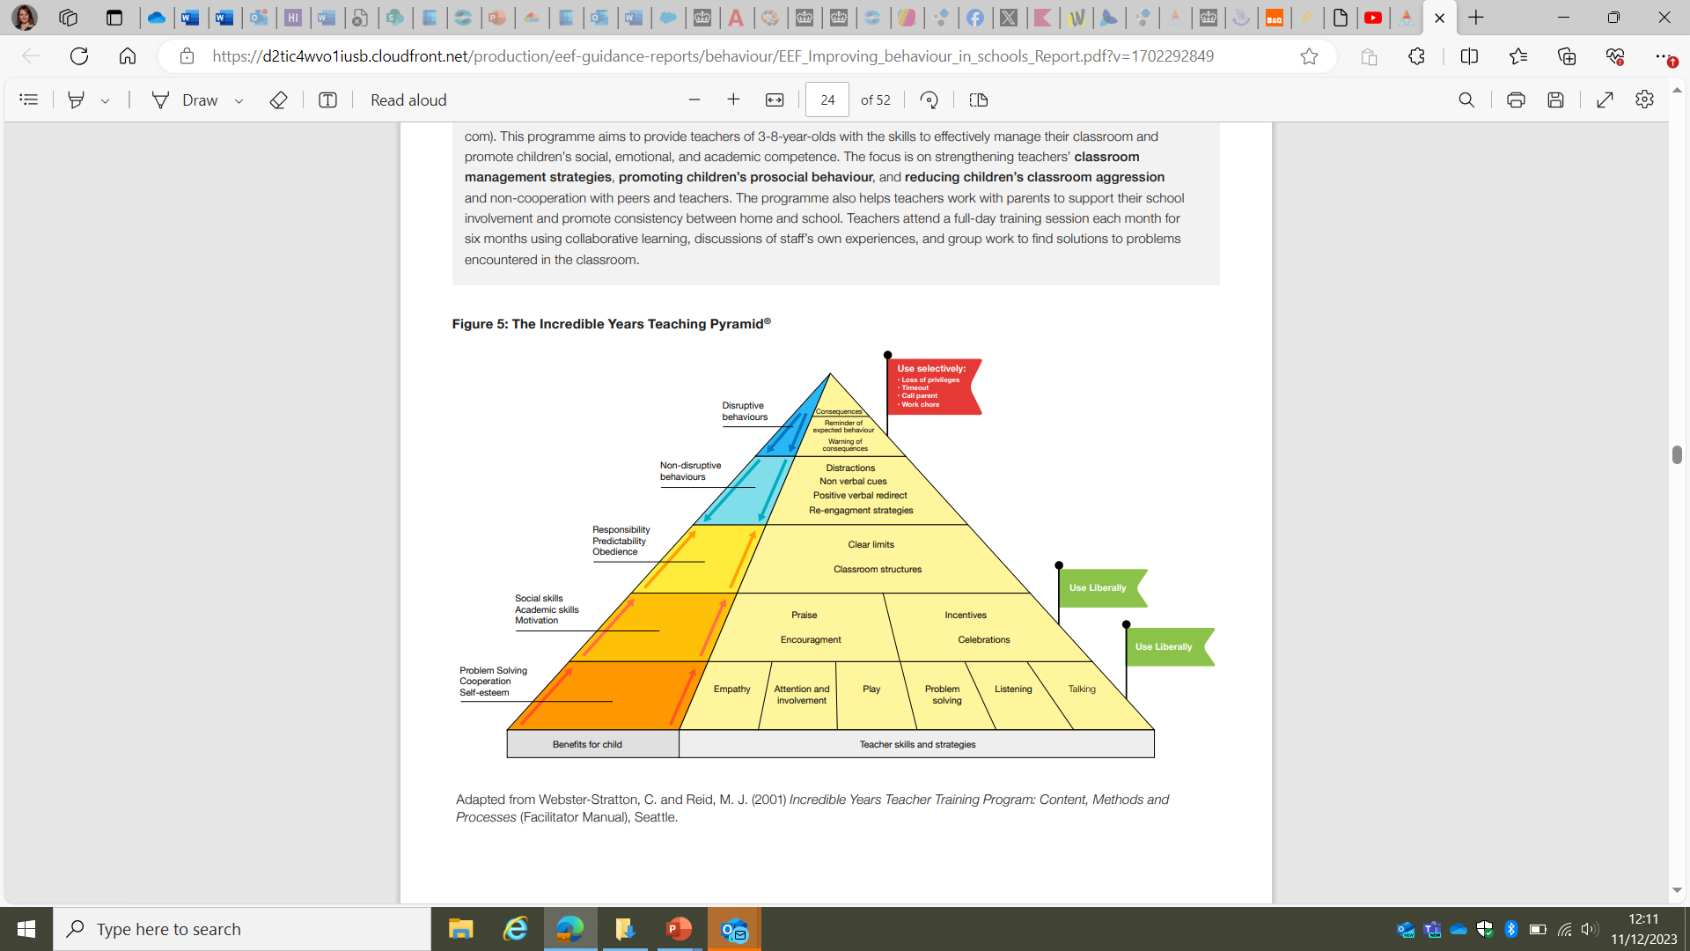
- Each class collaboratively develops a class charter of behaviour expectations that is agreed and referenced daily. These class charters incorporate the Jigsaw Charter (from our PSHE Curriculum) and may include:
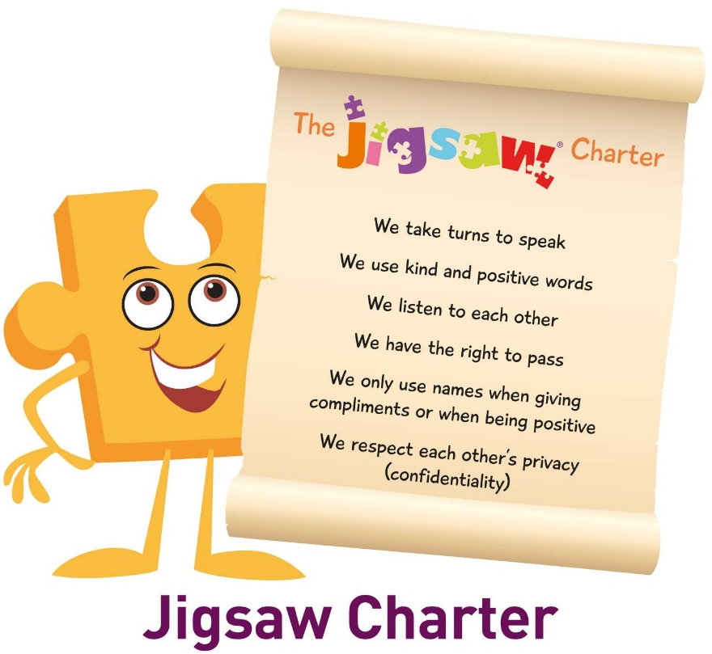

- Learning and Living behaviours are displayed in classrooms and around school
- All school staff explicitly model the learning and living behaviours alongside the modelling of good manners and courtesy
- Staff use consistent language when discussing relationships and behaviours (See Toolkits)
- Staff use the language of the learning and living behaviours when celebrating work and sharing success
- Staff praise the behaviours ‘we want to see more of’
- There is a termly focus on each learning and living behaviour in assemblies
- Our school and class assemblies make links to Fundamental British Values and the UNCRC
- Our PSHE Curriculum reinforces the learning and living behaviours through the Jigsaw Lessons and Jigsaw Circles.

6. Definitions
Uncooperative Behaviour (Poor Choices) can be defined as but not limited to:
    - Disruption in lessons, in corridors between lessons, and at break and lunchtimes
    - Not trying their best
    - Being unkind to others
    - Being disrespectful
    - Not following the class charter

Serious Poor Behaviour is defined as:
    - Vandalism
    - Theft
    - Fighting or harming others
    - Racist, sexist, homophobic or discriminatory behaviour
    - Possession of any prohibited items (e.g., knives, scissors, stolen items, inappropriate images etc)
    - Repeated breaches of the school expectations/class charter
    - Any form of bullying
    - Harassment, meaning unwanted conduct including those of a sexual nature, such as:
inappropriate comments, jokes, or taunting
    - Online harassment such as unwanted comments and messages (including on social media), sharing of inappropriate images and/or videos, or sharing of unwanted explicit content.

Bullying is defined as:
- Repetitive, intentional harming of one person or group by another person or group, where the relationship involves an imbalance of power.
Bullying is, therefore:
        - Deliberately hurtful
        - Repeated, often over a period of time
        - Difficult to defend against
Bullying can include:
TYPE OF BULLYING | DEFINITION
Emotional | Being unfriendly, excluding, tormenting
Physical | Hitting, kicking, pushing, taking another’s belongings, any use of violence
Prejudice-based and discriminatory, including:  - Racial  - Faith-based  - Gendered (sexist)  - Homophobic/biphobic  - Transphobic  - Disability-based | Taunts, gestures, graffiti, or physical abuse focused on a particular characteristic (e.g., gender, race, sexuality)
Sexual | Explicit sexual remarks, display of sexual material, sexual gestures, unwanted physical attention, comments about sexual reputation or performance, or inappropriate touching
Direct or indirect verbal | Name-calling, sarcasm, spreading rumours, teasing
Cyber-bullying | Bullying that takes place online, such as through social networking sites, messaging apps or gaming sites

Fundamental British Values are defined as:
- Democracy: making decisions together, for example giving opportunities to develop enquiring minds in an atmosphere where questions are valued.
- Rule of law: understanding rules matter as cited in Personal Social and Emotional development for example collaborating with children to create rules and codes of behaviour.
- Individual liberty: freedom for all, for example reflecting on their differences and understanding we are free to have different opinions
- Mutual respect and tolerance: treat others as you want to be treated, for example sharing and respecting other’s opinions.
These underpin what it is to be a citizen in a modern and diverse Great Britain, valuing our community and celebrating the diversity of the UK.

Protected Characteristics are defined as:
- The right not to treated less favourably, or subjected to an unfair disadvantage, by reason of a characteristic.
- Types of protected characteristics include age, gender reassignment, being married or in a civil partnership, being pregnant or on maternity leave, disability, race, religion or belief, sex, and sexual orientation.
- The Equality Act 2010 legally protects everyone from discrimination Equality Act 2010: guidance - GOV.UK (www.gov.uk)
- All children are protected from discrimination in education

7. Roles and Responsibilities
The Local Governing Board (LGB) is responsible for:
Reviewing this procedure in conjunction with the Headteacher and monitoring its effectiveness, holding the Headteacher to account for its implementation.
The Headteacher is responsible for:
Reviewing this procedure in conjunction with the staff and the LGB. The Headteacher will also approve this procedure.
Ensuring that the school environment encourages positive, respectful behaviour and that staff are equipped to deal effectively with poor behaviour. For example, through supervision and training.
Monitoring how staff implement this procedure to ensure rewards and sanctions are applied consistently.
Monitoring behviour incidents and using this to review policies and procedures.
Supporting restorative conversations with children.
Staff are responsible for:
Implementing this procedure consistently
Supporting children to set and understand clear expectations through the implementation of a class charter
Modelling positive behaviour and language
Reflecting upon actions taken through professional discussion and supervision
Maintaining a positive mindset
Staying calm
Sharing practice with others and engaging in solution focussed circles
Knowing each child and their family well
Setting the tone and context for positive behaviour e.g. greeting pupils in the morning with a smile and concluding the day positively
Starting each day, afresh
Creating a calm and engaging learning environment
Establishing routines that all children can access e.g. clear expectations, pictorial timetable
Providing a personalised approach to the specific behavioural needs of children in conjunction with parents and, where appropriate, with the SENDCO (Special Educational Needs Coordinator)
Liaising with parents around personalised approaches to behavioural needs and/or specific incidents of behaviour
Sharing information with relevant staff members about behaviour incidents and recording behaviour incidents on Bromcom.
Recording incidents using ABCs (or behaviour logs when a more personalised approach is needed).
- Antecedents (A): what happened directly before the behaviour occurred
- Behaviour (B): the specific action(s) or behaviour of interest and
- Consequences (C): what happened directly after the behaviour occurred
Parents are responsible for:
Supporting their child in adhering to class charter/school expectations
Engaging with school to support positive behaviour and find solutions cooperatively
Informing the school of any changes in circumstances that may affect their child’s behaviour
Discussing any behavioural concerns with the class teacher promptly
Children are responsible for:
Recognising their rights
Listening to everyone in the school community and modelling ‘LOVELY LISTENING’ and ‘SUPER SMART SITTING’ where appropriate
Learning strategies that support self-regulation
Informing a member of staff if they are worried or unhappy
Using the language of feelings to express themselves including reference to ‘The Zones of Regulation’ - Blue, Green, Yellow and Red Zone
Making it possible for all pupils to learn
Respecting the rights of others
Maintaining a positive mindset
Moving around the school respectfully and safely modelling ‘WONDERFUL WALKING’
Learning ways to take care of themselves, others, and the school
Wearing the appropriate school uniform with pride

8. Positive Mindset Toolkit
We strive to have a positive mindset throughout the school and when supporting positive behaviours and relationships.
Fradley Park Staff’s Mindset | Fradley Park Children’s Mindset
The children are capable. With the right support, they can solve their own problems.  When children make poor choices, they are communicating with me, and it is an opportunity to help them learn.  Everyone in our school community deserves respect, and I play a significant role in modelling respect for all. | I can solve my own problems.  I can fix my mistakes and become a better person and community member.  My actions impact others.  I can ask for help when I need it.  I need my community, and my community needs me.

9. Rewards and Sanctions Toolkit
Rewards
Praise Phrases
You are showing... (insert LL behaviour here)
I like it because....
I am proud of you because...
You should be proud of yourself because...
I can see that you have worked really hard on this. Shall we ask your friends what they think? (Public praise – involve peers in looking and feedback positive praise)
You are trying hard (name)...keep going (In the moment praise during activity)
Fantastic! You remembered....
Much better...I bet you could even...
Remember when you couldn’t... but you (insert LL behaviours) and now you can....
That’s a great start, I can see that you’re...
You must have been practising!
Pride Phrases
Tell me about it/this.
What do you like the most?
Why are you proud of it?
How do you feel?
Who would you like to show? What do you think they will say?
Which learning and living behaviour do you think you used today? (Use display as a prompt)
Would you like to display your work? Why?
Rewards
A variety of strategies for rewards are used within the school. Some of these are outlined below:
- Stickers (Ask me about…)/stamps
- Notes, messages, emails home
- Celebration Assembly Awards (Star of the Week)
- The Golden Book
- Headteacher’s Awards
- Special responsibilities/privileges
- House points (Anson, Wellington, Halifax, Sterling) in relation to our focused Learning and Living Behaviours.
- Showcasing finished pieces of work/observations of skill and process – Displays, Tapestry, Newsletter
- Class Dojo recognition and rewards (linked to Learning and Living Behaviours/School Values)
Class Dojo
Class Dojo is used as a mechanism to promote positive behaviours around the school quickly and easily, promoting consistency in approach across the whole school. Real-time feedback instantly encourages children to choose positive behaviours through visual and auditory prompts, rather than verbal prompts, leading to a calm classroom for all. The extrinsic motivation of receiving ‘Dojo Points’ will eventually develop intrinsic motivation within classrooms, leading to all children making increasingly positive behaviour choices.

Children can achieve ‘Dojo Points’ through the following categories:
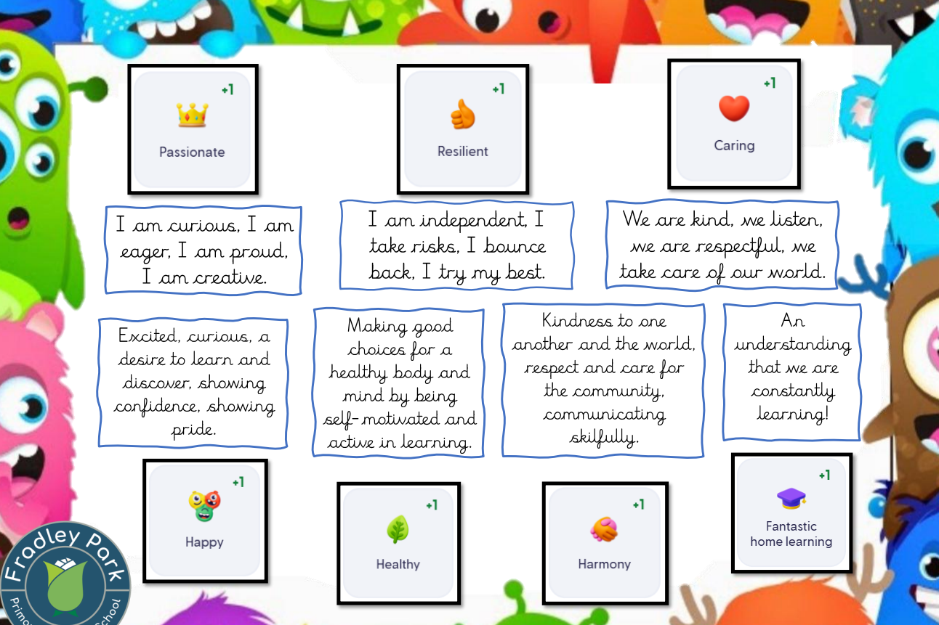
To ensure consistency, posters are displayed in each classroom and examples of positive behaviours are detailed to ensure equity for all children.

Children are able to earn rewards through Class Dojo which are awarded weekly:
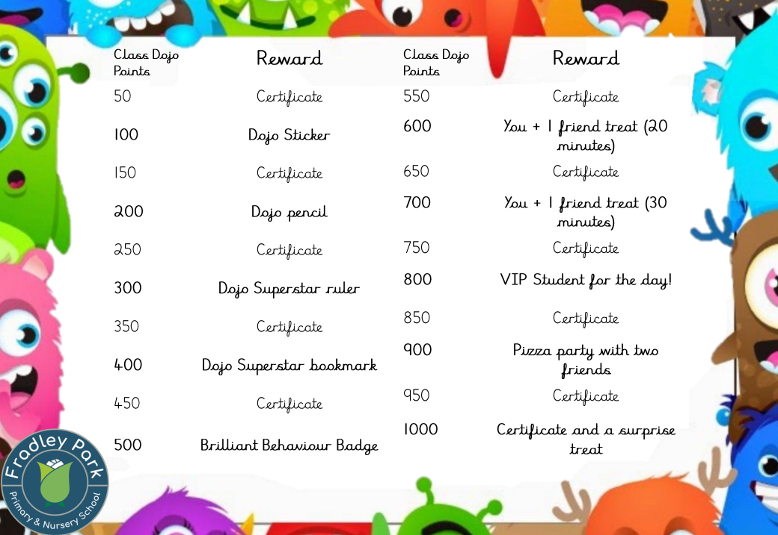

Sanctions
When dealing with difficult behaviour, there are three main considerations:
- Care for the individual involved.
- Ensuring a prompt, fair and consistent response
- Meeting with parents/carers if the behaviour is a cause for concern.

The school may use one or more of the following sanctions in response to unacceptable behaviour:
- Active ignoring and praising others (if appropriate/safe to do so)
‘I have got 5 children sitting listening, looking at me… now I have got 7 children… etc. Fantastic, I now have the whole class who are ready for their learning.’
‘Everybody look at … she is sat ready for learning.’
‘I am really proud of you… you are being a super sitter.’
- A verbal reminder of Class Charter expectations to the class
‘What is on our class charter?’
- A direct verbal prompt to the child about their behaviour and the impact it is having on others
‘… is trying to learn, can you help them? How can you do this?’
- A warning about ‘Time in’ (time within the classroom)
- ‘Time in’
‘Because you have not followed our Class Charter/expectations, I would like you to have some thinking time/reflection time.’
- Thinking time - sand timer (2 minutes), sitting near an adult, sitting away from the group.
- Reflection time with another adult - Restorative conversation, feeling review, time to regulate, calm down time/area, co-regulation walk/task, Zones of Regulation prompts.
- ‘Time out’ of the classroom with a responsible adult
Handover conversation to take place in front of the child, ‘… needs some space away from class to reflect on their behaviour as they are making poor choices at the moment. I would like them to stay with you for 5 minutes and then return to class ready to make some good choices.’
- Referring the pupil to a senior member of staff
- Referring to Headteacher – visit to classroom
- Phone call home to parents
- Behaviour Plan

Restorative Conversations
Restorative conversations should be focused on deepening your understanding of a child’s needs, supporting children in the development of new skills, and helping children to take responsibility for their actions and repair their relationships. The important thing is not pointing the finger of blame or causing the children to feel defensive.
- What happened?
- What were you thinking and feeling at the time?
- What has been affected and in what way?
- How could things have been done differently?
- What do you think needs to happen to make things right?
If appropriate:
- Use comic strip conversations. Comic strip conversations use stick figures and symbols to represent social interactions and abstract aspects of conversation, and colour to represent feelings and emotions.
- Puppets/objects to encourage children to talk about their feelings in a safe way.

Suspensions and Permanent Exclusions
As a school, we work hard to avoid suspension or permanent exclusion of a pupil, but serious offences may result in a fixed term suspension or permanent exclusion. In these situations, we follow the guidance laid out in the JTMAT (John Taylor Multi Academy Trust) Behaviour Policy and the guidance laid out by Department for Education in Suspension and Permanent Exclusion from maintained schools, academies and pupil referral units in England, including pupil movement (publishing.service.gov.uk) and Behaviour in schools guidance (publishing.service.gov.uk) . The JTMAT have developed clear procedures for excluding pupils whose poor behaviour has become quite unacceptable and this can be read in Behaviour Policy (jtmat.co.uk) .

Zero-Tolerance Approach to Sexual Harassment and Sexual Violence
The school will ensure that all incidents of sexual harassment and/or violence are met with a suitable response, and never ignored.
Pupils are encouraged to report anything that makes them uncomfortable, no matter how ‘small’ they feel it might be.
The school’s response will be:
- Proportionate
- Considered
- Supportive
- Decided on a case-by-case basis
Off-site Behaviour (e.g., School educational visits)
This procedure applies off site as well as in school. Staff apply the same behaviour procedures and pupils understand that the same expectations apply.
Where staff have concerns regarding the behaviour of pupils on visits, they should speak with the Headteacher/ EVC (Educational Visits Coordinator) so that necessary arrangements can be put into place to ensure the safety of all on the trip.

10. Physical and Restrictive Interventions & Positive Handling
Please see associated documents and procedures which explains how members of school staff have a legal power to use reasonable force in certain circumstances.
Statutory Guidance: Use of reasonable force and other restrictive interventions guidance
DRAFT Physical Intervention Procedure April 2026.docx
The use of restrictive interventions, including reasonable force and seclusion, can have a significant impact on the pupils, staff members and parents involved, as well as the wider classroom. However, there are times when the use of restrictive interventions will be lawful and necessary; for example, to keep individuals and the wider school community safe.
Allowing a child to hurt themselves or others, damage property or put themselves in a dangerous situation is never in the best interests of the child.
Physical and/or restrictive intervention may be necessary to prevent or stop a pupil from:
1. causing injury to themselves or others
2. committing a criminal offence
3. damaging property
4. causing disorder among pupils at the school, whether during a teaching session or otherwise

Incidents of physical restraint must:
      - Always be used as a last resort when staff have considered: Is it necessary? Is it proportionate? Has the pupil’s welfare been considered?
      - Use the least amount of force or least restrictive intervention necessary for the least amount of time required to reduce the relevant risks.
      - Be used in a way that maintains the safety and dignity of all concerned
      - Never be used as a form of punishment
      - Be recorded on a Physical Intervention Report Form and uploaded to the child’s ‘My Concern’ profile and reported to parents
Where there is increased likelihood in the need to use reasonable force and/or other restrictive interventions to support the needs of a specific child, then training will be accessed through the Educational Psychologist. An individual Risk Assessment will then be implemented alongside a Behaviour Support Plan.

11.Pupil Support
Fradley Park Primary and Nursery School is committed to enabling all children, including those with SEND, to access education successfully and part of this commitment is ensuring that there is a high standard of behaviour throughout the school.
The school recognises its legal duty under the Equality Act 2010 to prevent pupils with a protected characteristic from being at a disadvantage. Consequently, our approach to challenging behaviour may be adapted to cater to the needs of the pupil.
The school’s special educational needs co-ordinator (SENDCo) will evaluate a pupil who exhibits challenging behaviour to determine whether they have any underlying needs that are not currently being met.
Where necessary, support and advice will also be sought from specialist teachers, an educational psychologist, medical practitioners, and/or others, to identify or support specific needs.
When acute needs are identified in a pupil, we will liaise with external agencies and plan support programmes for that child. We will work with parents to create the plan and review it on a regular basis.
All staff are aware of the importance of recognising children’s individual needs and with this in mind make reasonable adaptations to ensure a personalised approach is taken with discretion for those children identified as having a SEND.
The school recognises that changes in behaviour may be an indicator that a pupil needs help or protection. We will consider whether a pupil’s misbehaviour may be linked to them suffering, or being likely to suffer, significant harm. Where this may be the case, we will follow our safeguarding procedures.

12. Pupil Transition
To ensure a smooth transition to the next year, pupils have transition sessions with their new teacher(s). In addition, staff members hold transition meetings and events
To ensure behaviour is continually monitored and the right support is in place, information related to pupil behaviour issues may be transferred to relevant staff at the start of the term or year.
We also offer an enhanced SEND transition programme both with pupils and parents to ensure all pupils’ needs are being met.
In the case of new pupils transitioning to our school, the SENDCo (Special Educational Needs Coordinator) will liaise with staff at the pre-school settings and parents to arrange additional support.

13. Training
Behaviour management will also form part of continuing professional development and the procedures will be shared and reviewed as a whole school team on an annual basis.

14. Monitoring Arrangements
A copy of this policy is available to all staff and parents and is published on the school website.
This policy is reviewed every two years by the Governors.
Signature 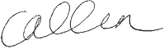 Headteacher Date: 14/01/26
Signature 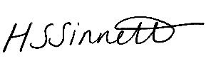 Chair of Governors Date: 14/01/26

